KING ARTHUR

ABOUT HISTORY
King Arthur was a legendary British leader who, according to medieval histories and romances, led the defense of Britain against Saxon invaders in the late 5th and early 6th centuries. The details of Arthur's story are mainly composed of Welsh and English folklore and literary invention, and modern historians generally agree that he is unhistorical. The sparse historical background of Arthur is gleaned from various sources, including the Annales Cambriae, the Historia Brittonum, and the writings of Gildas. Arthur's name also occurs in early poetic sources such as Y Gododdin.
Arthur is a central figure in the legends making up the Matter of Britain. The legendary Arthur developed as a figure of international interest largely through the popularity of Geoffrey of Monmouth's fanciful and imaginative 12th-century Historia Regum Britanniae. In some Welsh and Breton tales and poems that date from before this work, Arthur appears either as a great warrior defending Britain from human and supernatural enemies or as a magical figure of folklore, sometimes associated with the Welsh otherworld.

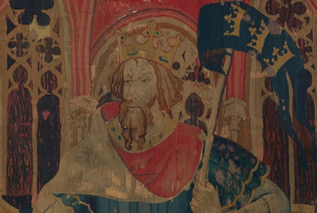

Development of the Legends
Like many heroes of myth and legend, Arthur is of royal birth. However, until he comes of age and claims his throne, he does not know the truth about who he is. Arthur must defeat many enemies before becoming king. Some of these defeated kings and noblemen are so impressed by him that they swear to remain his loyal servants.

Like Finn, the legendary Irish hero, Arthur is surrounded by a band of devoted followers. In early versions of the tales, these were warriors and chieftains, but once the tales were set in the Middle Ages, his followers became courtly knights. Their number varies from a dozen to more than a hundred, depending on the source. A few of the knights, especially Gawain, Galahad, and Lancelot, emerge as distinct personalities with their own strengths and weaknesses.

Not all the legends focus on King Arthur. Many deal with the Knights of the Round Table, who ride out from King Arthur's court at Camelot to do good deeds and perform brave feats. The most honorable and difficult of all their actions is the search for the Holy Grail. Of all the knights, only Galahad is pure enough to succeed in this quest.

Magical Power and Human Weakness Supernatural beings and events play an important part in the Arthurian legends. Before Arthur is born, his destiny is shaped by the wizard Merlin, who later serves as the king's adviser and helper. Another powerful magical figure is the witch Morgan Le Fay, who works for good in some versions of the legends and for evil in others. She is sometimes referred to as Arthur's half-sister.

Arthur becomes king by gaining possession of the enchanted sword Excalibur. There are two versions of how Arthur gets the sword. In one, Excalibur is in a stone, and all believe that whoever can pull the sword from the stone will be the true king. Arthur pulls the sword from the stone and claims the throne. In the other version, Arthur is given the sword by the” Lady of the Lake” (a water spirit probably of ancient Celtic origin).

Arthur and the Knights of the Round Table battle several giants and monsters—supernatural creatures that figure often in the legends—but the tragic aspect of the legends arises not from spells cast by wicked sorcerers or the actions of vicious enemies but from the behavior of people closest to the king. Guinevere, Arthur's queen, and Lancelot, his beloved friend and best knight, betray Arthur by becoming lovers. Like the appearance of the serpent in the Garden of Eden, their betrayal introduces disorder and deception into what had been a perfect world.

Mordred, Arthur's jealous nephew, uses Guinevere's affair to destroy the unity of the Round Table. Eventually, Mordred goes to war against Arthur. Some versions of the story make Arthur and his half-sister Morgause Mordred's parents, placing part of the blame for the fall of Camelot on the king's youthful sin of incest.

KING ARTHUR IN LITERATURE
Thomas Malory was the first to provide an English prose retelling of the legend in his Le Morte D'Arthur, published in 1485. Centuries later, Alfred Tennyson published his Idylls of the King throughout the latter half of the 1800s, telling the story of Camelot in the form of an epic poem.

The story of Arthur has continued to be interpreted by a variety of writers, including children's authors, comic-book scribes and novelists such as Marion Zimmer Bradley, whose Mists of Avalon (1982) looks at the legend from the female characters' perspectives.

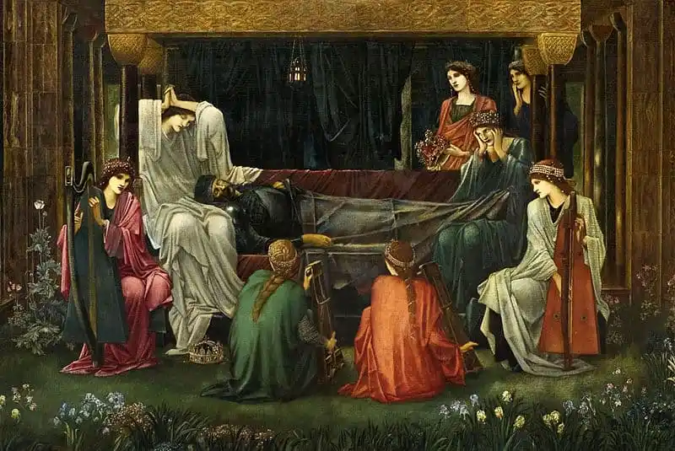

Broadway, Movies & TV ShoWS
In the 20th century, King Arthur also found his way to stage and screen. During the 1960s, the myth found a home on Broadway with the musical Camelot, which starred Richard Burton as Arthur. Later revivals would see Richard Harris — who starred in the 1967 movie version as well — and Robert Goulet portray the monarch. A more serious, grim take on Camelot was seen in the 1981 film Excalibur, with Helen Mirren in the role of Morgana, half-sister to the king. Fast forward to the next millennium where Antoine Fuqua directed King Arthur (2004), whose still fantastic plot relied more heavily on the idea that Arthur, here portrayed by Clive Owen, was a military leader against the Saxons. His life was also portrayed in the 2017 movie King Arthur: Legend of the Sword.

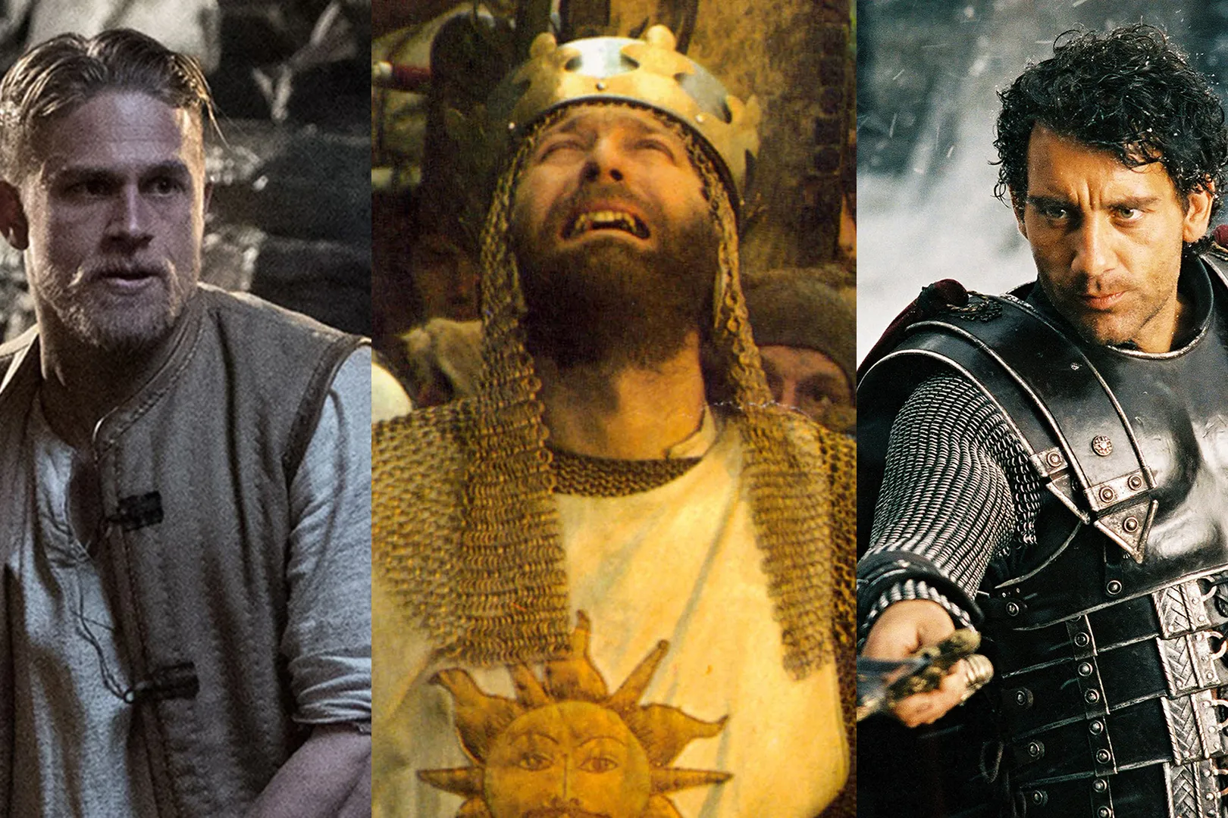

A SMALL REVISION

https://youtu.be/RBsY88Lir-A

Let's check what you have learned about King Arthur

When did Arthur led the defense of Britain against Saxon invaders?
1} in the late 5th and early 6th centuries 2} in the late 6th and early 7th centuries 3} in the late 4th and early 5th centuries

What did Arthur’s followers become?
1} courtly aristocrats 2} courtly knights 3} courtly crusades

Of all the knights, who was pure enough to succeed in the search of the Holy Grail?
1} Galahad 2} Gawain 3} Lancelot

Who works for good in some versions of the legends and for evil in others?
1} Lady of the Lake 2} Gawain 3} Morgan Le Fay

Who was the first to provide an English prose retelling of the legend in 1485?
1} Geoffrey of Monmouth's 2} Alfred Tennyson 3} Thomas Malory

Who novelist did look at the legend from the female characters perspectives?
1} Marion Zimmer Bradley 2} Richard Burton 3} Alfred Tennyson
A PROJECT BY JIM ZIOGAS

SOURCES
https://www.gq-magazine.co.uk/culture/article/king-arthur-movies-ranked
https://britishheritage.com/history/legend-king-arthur
https://interestingliterature.com/2020/09/10-of-the-best-books-about-king-arthur/
https://www.encyclopedia.com/history/encyclopedias-almanacs-transcripts-and-maps/arthurian-legends
https://www.britannica.com/topic/King-Arthur
https://www.biography.com/military-figure/king-arthur
https://en.wikipedia.org/wiki/King_Arthur

