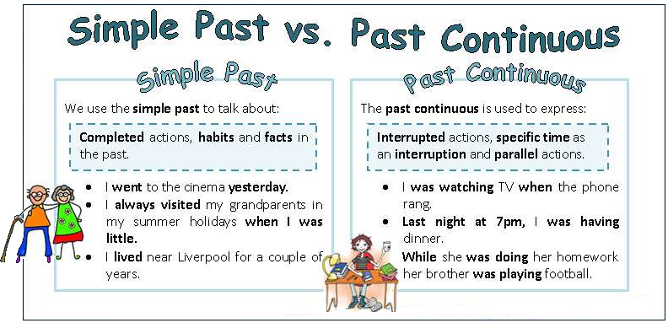

**A) CHOOSE THE CORRECT OPTION**

1.-Anthony **called/was calling** while I **parked/was parking** the car.

2.-Miranda **drove/was driving** to work when she **saw/was seeing** the accident.

3.-Thomas **didn’t watch/wasn’t watching** the film when Sonia arrived home.

4.-**Did he lie/was he lying** on the sofa at 5.30 yesterday?

5.-When I **left/was leaving** the office, the phone **rang/was ringing**.

6.-It **snowed/was snowing** in the mountains when we got up yesterday.

7.-Barbara **was living/lived** in Paris when she was 15 years old.

8.-I **was writing/wrote** my blog on the Internet while you **slept/were sleeping**.

9.-While David **was recovering/recovered** in hospital, I decorated the flat.

10.-When I **was waking /woke** up, I realized that it was **getting /got** dark.

**B) COMPLETE THE SENTENCES USING PAST SIMPLE OR PAST CONTINUOUS TENSE**

1.-Yesterday at 9.30 pm my parents …………………… (sit) in the garden …………………… (drink) some Coke.

2.- The chambermaid …………………………… (make) my bed in the hotel and …………………… (clean) the bathroom

while I was having breakfast.

3.- Somebody ……………………… (knock) on the door while I …………………………… (read) the newspaper.

4.-My brother ……………………… (buy) a lot of books when he ……………………… (live) in Cambridge.

5.-William ……………………………… (not meet) Sally at the airport last Sunday.

6.-Jerry ………………………… (have) dinner when t……………………………… (not go) to work.

8.-When I ……………………… (arrive) at the wedding, Miriam …………………… (introduce) me to some friends.

9.-Sarah ………………… (run) to catch the bus, when she ………………… (fall) down and ………………… (break) her ankle.

10.-Richard ……………………………… (teach) at the university when he ……………………… (meet) his wife.