***THE 2ND CONDITIONAL (PRE-CLASS THEORY)***

1. 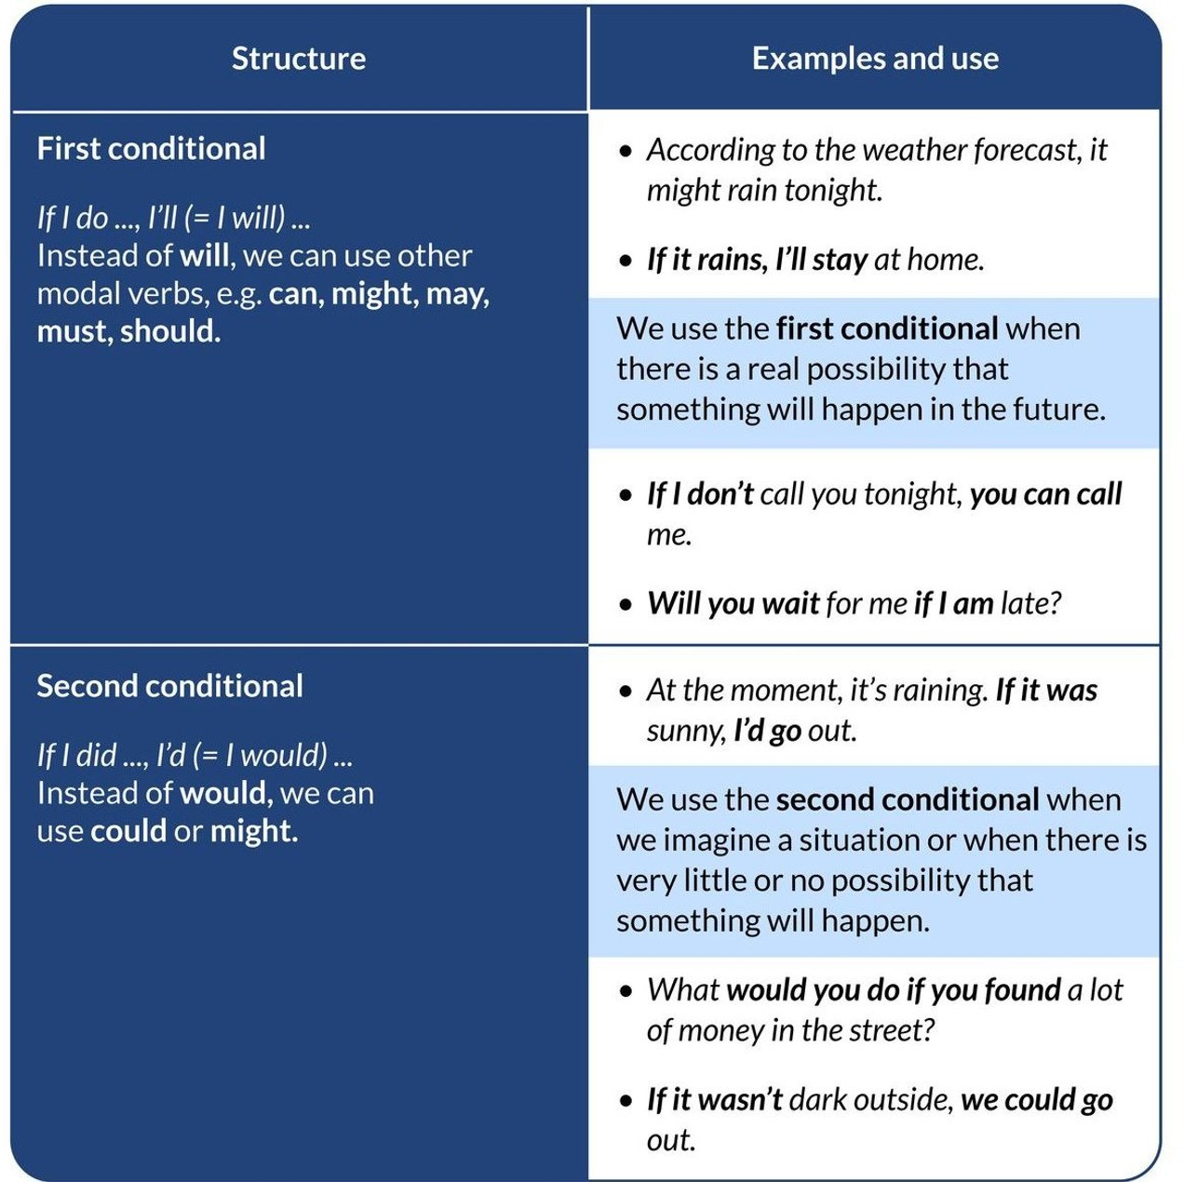Study the grammatical theory of the 2nd conditional

We use the second conditional to talk about unreal situations in the present or future.

Second conditional sentences are made up of two clauses, an *if + past simple* clause, and a

*would / wouldn't + infinitive* clause.

A second conditional sentence can begin with either clause, but if it begins with an *if* clause, you need to separate the two clauses with a comma.

Examples: If I won the lottery, I would buy a Ferrari.

I would buy a Ferrari if I won the lottery.

1. Watch the 2nd conditional theory video

<https://www.youtube.com/watch?v=PZD4Gl1tZqk>

1. Write down any questions you may have

***SEE YOU ALL IN CLASS ! ! ! ! !***