Scan the QR Code and see the result of your Homework Evaluation Assignment!!

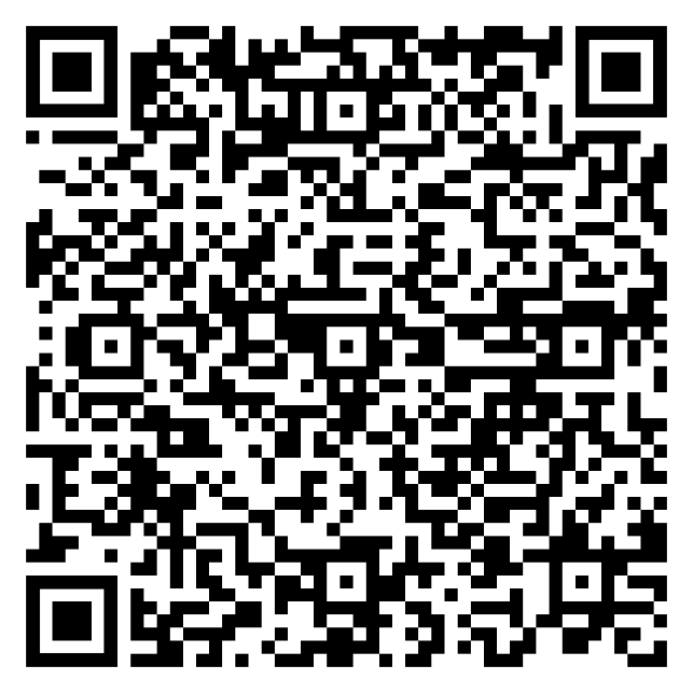



<https://docs.google.com/document/d/1D8jx6d7PrR5Y_JDdz_LZVsNdP-GHjQ479k4Zx7-5z8A/edit?usp=sharing>