PERE NOEL
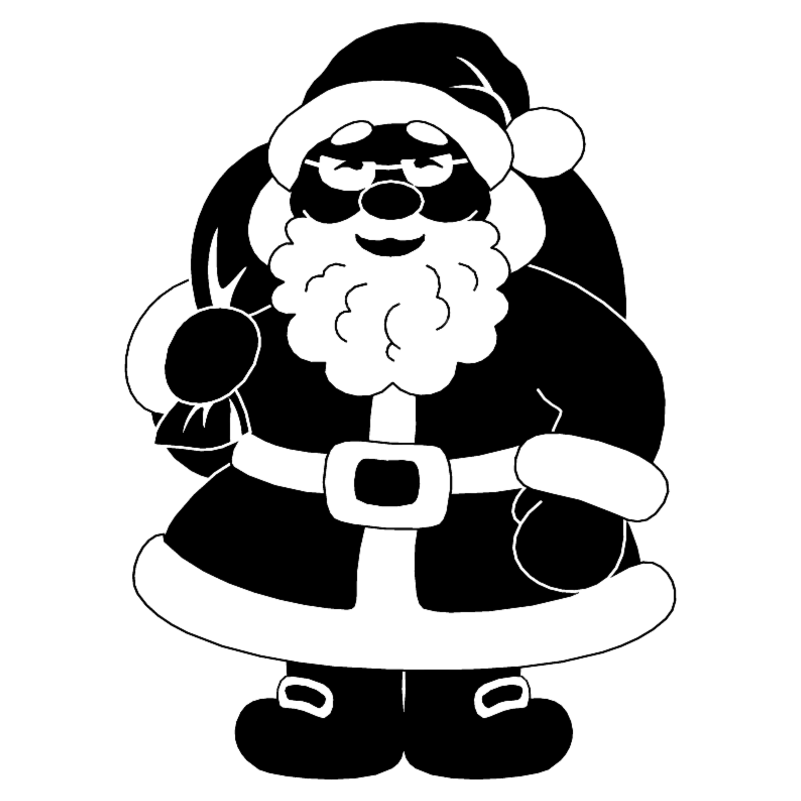
BONNET
HOTTE
GANTS
BARBE
MANTEAU
BOTTES
PERE NOEL

HOTTE

BOTTES

CEINTURE

BONNET

BARBE

MANTEAU

HOTTE

BOTTES

CEINTURE

BONNET

BARBE

MANTEAU

HOTTE

BOTTES

CEINTURE

BONNET

BARBE

MANTEAU

HOTTE

BOTTES

CEINTURE

BONNET

BARBE

MANTEAU

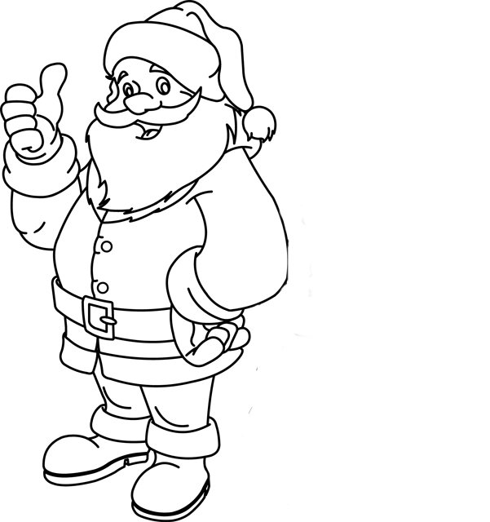

P | E | R | E |  | N | O | E | L

P | L | N | E |  | E | E | R | O

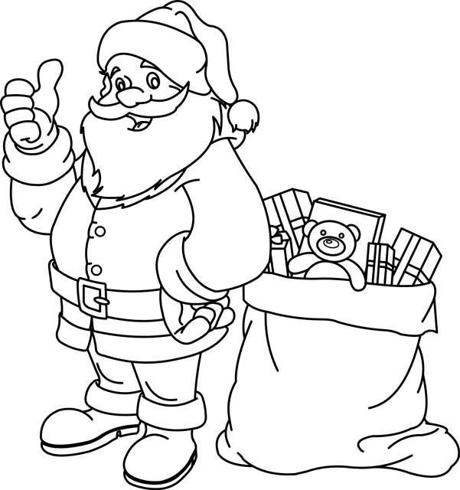

H | O | T | T | E

H | E | T | O | T

C | E | I | N | T | U | R | E

E | C | R | E | U | I | T | N

B | O | T | T | E | S

S | B | E | O | T | T
M | A | N | T | E | A | U

M | E | A | A | U | T | N
B | O | N | N | E | T

N | B | N | O | T | E
B | A | R | B | E

B | E | B | R | A

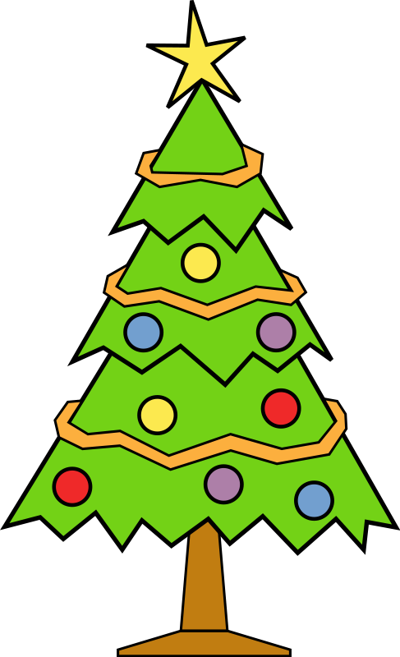

SAPIN DE NOEL
ETOILE
GUIRLANDE
BOULE
SAPIN
PIED
CADEAU
SAPIN DE NOEL

CADEAU

PIED

GUIRLANDE

ETOILE

BOULE

SAPIN

CADEAU

PIED

GUIRLANDE

ETOILE

BOULE

SAPIN

CADEAU

PIED

GUIRLANDE

ETOILE

BOULE

SAPIN

CADEAU

PIED

GUIRLANDE

ETOILE

BOULE

SAPIN

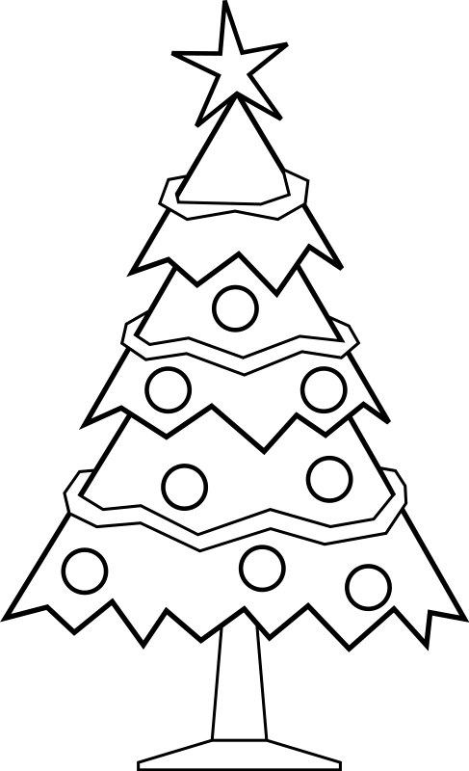
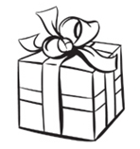

S | A | P | I | N

N | S | I | A | P

P | I | E | D

E | P | I | D

E | T | O | I | L | E

E | E | L | T | I | O

C | A | D | E | A | U

D | E | A | A | U | C

B | O | U | L | E

O | U | E | L | B

G | U | I | R | L | A | N | D | E
L | G | A | U | N | I | D | R | E

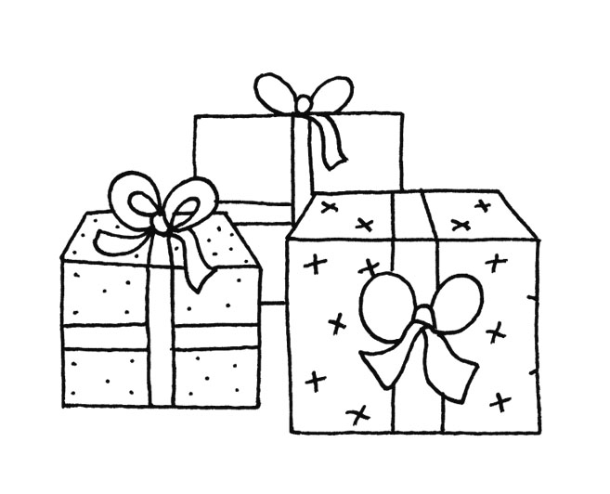
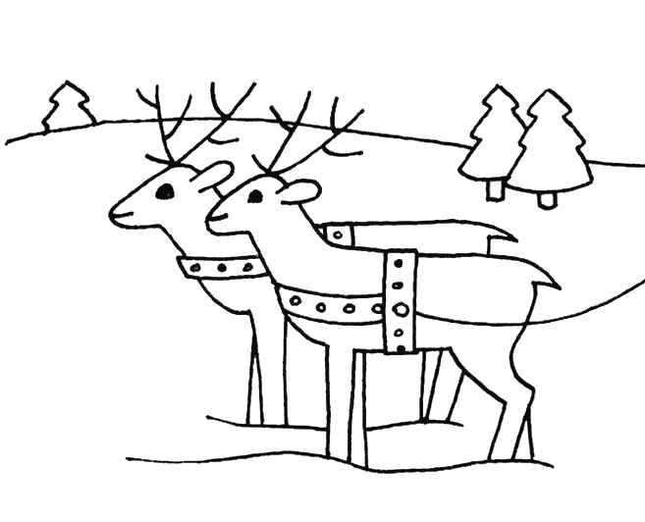
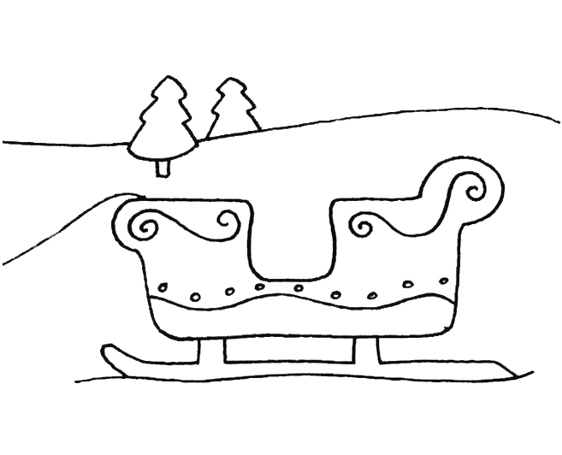
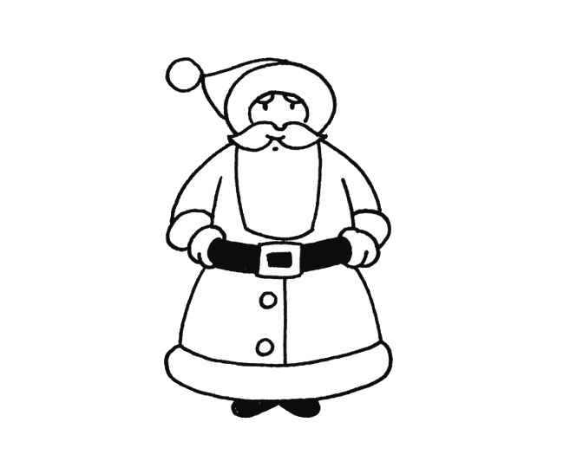
LE TRAINEAU
CADEAUX
RENNES
TRAINEAU
PERE NOEL
BOIS
LE TRAINEAU

RENNES

TRAINEAU

PERE NOEL

CADEAUX

BOIS

RENNES

TRAINEAU

PERE NOEL

CADEAUX

BOIS

RENNES

TRAINEAU

PERE NOEL

CADEAUX

BOIS

RENNES

TRAINEAU

PERE NOEL

CADEAUX

BOIS

B | O | I | S

I | B | O | S

R | E | N | N | E

R | E | E | N | N

P | E | R | E |  | N | O | E | L

P | L | N | E |  | E | E | R | O

C | A | D | E | A | U | X

D | E | A | A | U | C | X

T | R | A | I | N | E | A | U

T | A | U | E | R | A | N | I

