Popular books that were burned by Nazis

**02/15'A Farewell to Arms' by Ernest Hemingway**

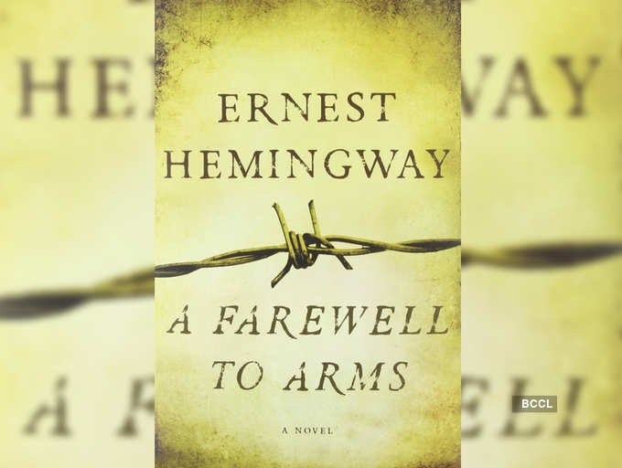

Set against the backdrop of World War I, the book is a first-person account of a love affair between an American expatriate Frederic Henry and an English nurse, Catherine Barkley. Based on Hemingway's own experiences in the Italian campaigns during the First World War, the book is considered one of the best literary works that depict war.  
  
Image: Harper Perennial

**03/15'How I Became a Socialist' by Helen Keller**

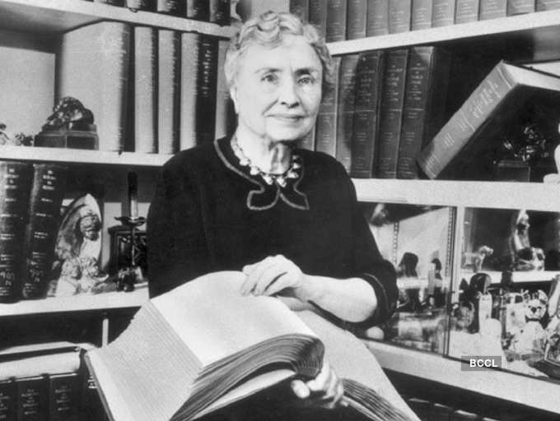

Helen Keller has been an inspiring figure for a lot of reasons. She became an author and a prominent voice in education despite her inability to see, hear or speak. A member of the Socialist Party, Helen became one of the leading humanitarians of 20th century, as well as co-founder of the American Civil Liberties Union (ACLU). 'How I Became a Socialist' is a radical essay about her beliefs, thoughts and ideologies that appeared in the New York Call, a daily newspaper of the Socialist Party, on November 3, 1912.  
  
Image: prosper.org.au

**04/15'All Quiet on the Western Front' by Erich Maria Remarque**

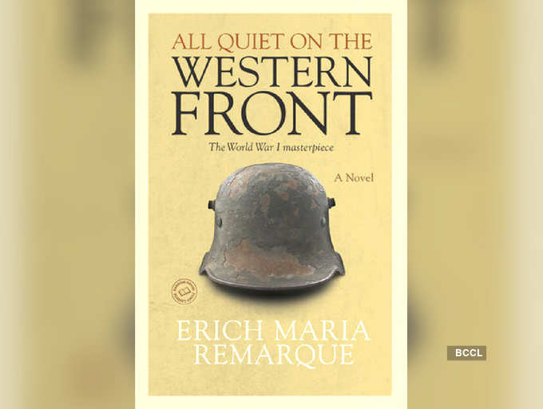

Originally written in German, the book is penned by a German veteran of World War I. In the book, Remarque shows how German soldiers were physically and mentally stressed during the war, and were also detached from civilian life that haunted many of these soldiers for a long time. Needless to say, the book was not well received by the Nazi government.  
  
Image: Penguin Random House

**05/15'The Time Machine' by H.G. Wells**

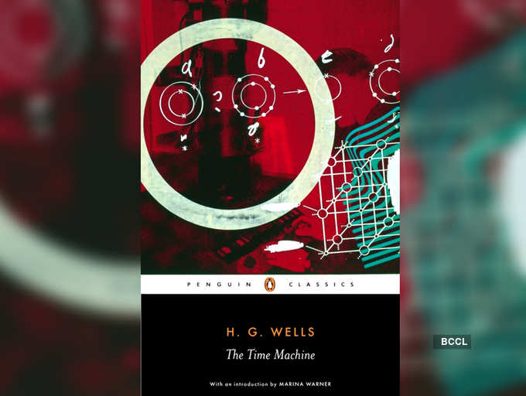

This science fiction novella popularized the concept of time travel by using a vehicle that allows one to travel forwards or backwards in time, purposely and selectively. It is written as a time traveller’s firsthand account of his journey 800,000 years beyond his own era.  
  
Image: Penguin Random House

**06/15'The Metamorphosis' by Franz Kafka**

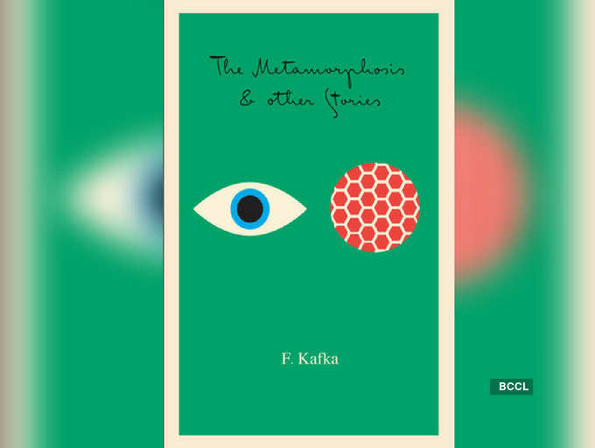

One of Kafka's best-known works, 'The Metamorphosis' is a short novel that follows salesman Gregor Samsa. Samsa is astonished to wake-up one morning to find himself transformed into a huge insect and thereby struggling to adjust to this new condition. The book has been widely critiqued and well-received, with differing interpretations being offered.  
  
Image: Penguin Random House

**07/15'War of the Worlds' by H.G. Wells**

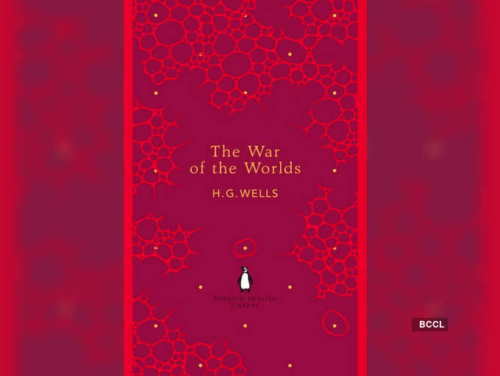

Science fiction writer H.G. Wells' 'War of the Worlds' is one of the first stories in literature to detail a conflict between mankind and extraterrestrial species. The story is written as a first-person narrative of two characters -- one is an unnamed character from Surrey and the second is his younger brother who lives in London. The book is said to have even influenced the work of Robert H. Goddard, who invented both the liquid-fueled rocket and multistage rocket, inspired by the book, which resulted in the Apollo 11 Moon landing 71 years later.  
  
Image: Penguin Random House  
[READMORE](javascript://)

**08/15'The Sun Also Rises' by Ernest Hemingway**

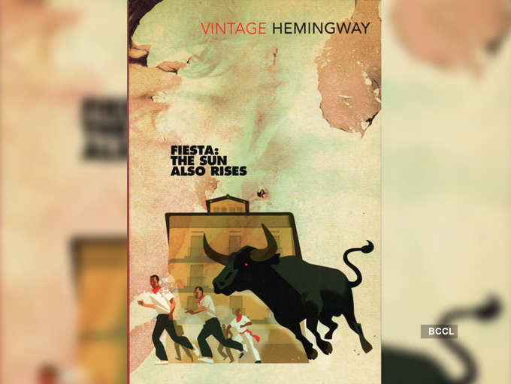

The book is about a group of expatriates from Britain and America who visit the Festival of San Fermín in Pamplona to watch the running of the bulls and the bullfights. It presents a poignant look at the disillusionment and angst of the post-World War I generation.  
  
Image: Penguin Random House

**09/15'The Communist Manifesto' by Karl Marx and Friedrich Engels**

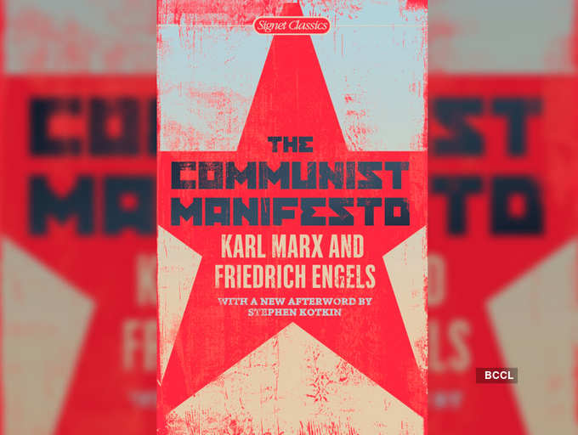

'The Communist Manifesto' is one of the most important political theories ever formulated. It is a political pamphlet written by the German philosophers where they presented their idea of Communism, in which they envision a classless or stateless society and argued that the exploitation of industrial workers will eventually lead to a revolution in which Capitalism is overthrown.  
  
Image: Penguin Random House

**10/15The Invisible Man by H.G. Wells**

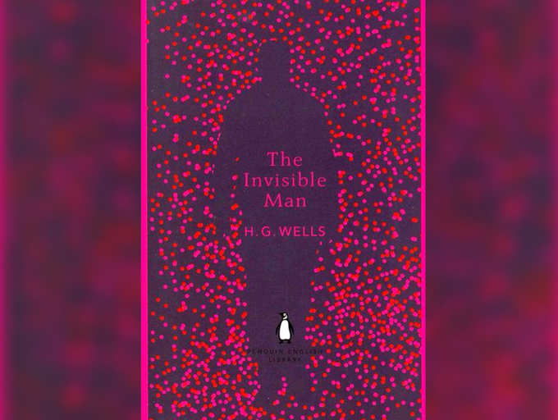

Thoroughly entertaining and nerve-wracking, 'The Invisible Man' is a science-fiction classic. The book presents a piercing look into human nature. A scientist by profession and an enthusiast of random and irresponsible violence, the protagonist Griffin is an iconic character in horror fiction.He is consumed with his greed for power and fame, and is the model of science without humanity.

**11/15'A Brave New World' by Aldous Huxley**

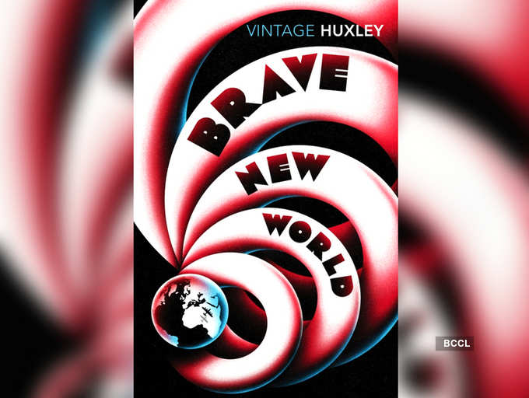

Aldous Huxley's dystopian classic is set in a futuristic world of genetically modified citizens and an intelligence-based social hierarchy. The book looks into huge scientific progressions in reproductive technology, sleep-learning, psychological manipulation, and classical conditioning that were at first believed to make a utopian society, but goes challenged by an outsider.  
  
Image: Penguin random House

**12/15'Ulysses' by James Joyce**

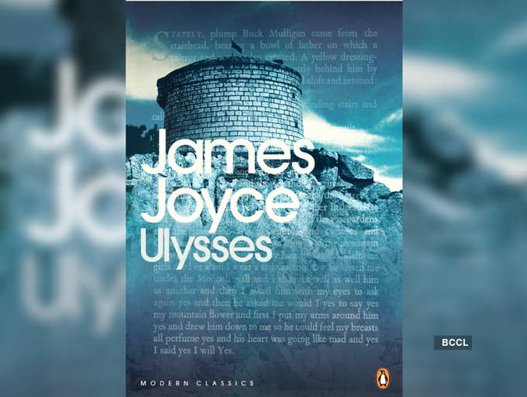

A modernist novel by James Joyce, 'Ulysses' is loosely based on the Odyssey. Capturing a day in the life of a range of characters, the book draws structural correspondences between the characters and experiences of the protagonist Leopold Bloom -- all Dubliners. The book also throws light on events and themes of the early 20th-century modernism, Dublin, and Ireland's precarious relationship with Britain.  
  
Image: Penguin Random House

**13/15'Lolita' by Vladimir Nabokov**

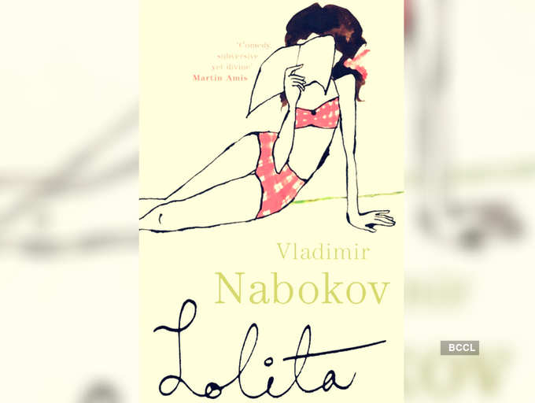

The book follows the unreliable narrator Humbert Humbert, a scholar and a romantic, hopelessly in love with a 12-year-old, Dolores Haze, who he lovingly calls "Lolita". This landmark in literature is known for being funny, bold, heart-breaking and full of ingenious wordplay. The book is also considered one of best English-language novels of the 20th century.  
  
Image: Penguin Random House

**14/15'Mother' by Maxim Gorky**

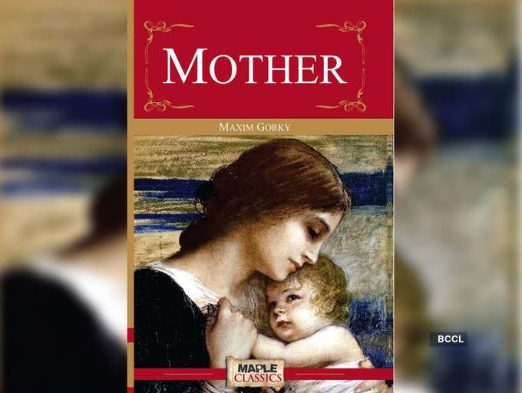

Maxim Gorky's pathbreaking book 'Mother' was written in 1906 about revolutionary factory workers. After the defeat of Russian's first revolution in 1905, Gorky wanted to propagate the spirit of the proletarian movement and his political agenda among readers through his work. The novel is based on real-life events and follows the life of Anna Zalomova and her son Piotr Zalomov.  
  
Image: Maple Classics

**15/15'War and Peace' by Leo Tolstoy**

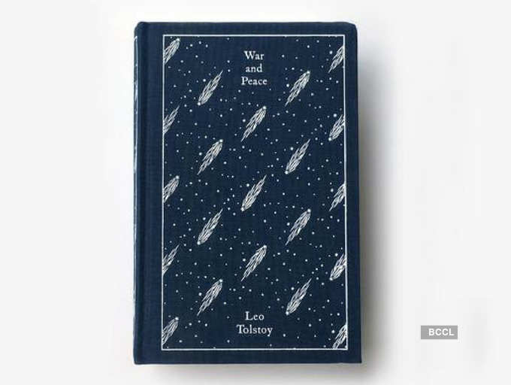

Tolstoy is known for writing voluminous books. His magnum opus 'War and Peace', follows the French invasion of Russia and through the stories of five Russian aristocratic families, also tells of the impact of the Napoleonic era on Tsarist society in Russia. As the army invades their country, Tolstoy wonderfully depicts characters from diverse backgrounds -- peasants, nobility, and civilians, as they grapple with their contemporary culture and problems.