1. **Inversion in conditional sentences**

Conditional sentences with inversion are **more formal** than those that follow the usual word order.

**1st Conditional**

In real conditionals inversion is found with the modal verb **should**, but it is only used in formal language.

***Example:***

If he remembers his own name, we’ll be able to help him.

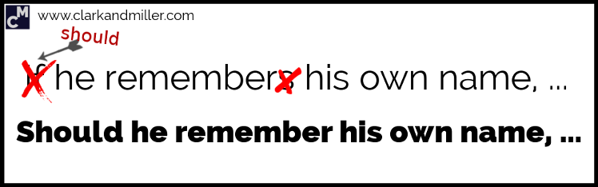

**Should** he remember his own name, we’ll be able to help him.

**2nd Conditional**

In unreal conditionals it is common to find inversions in formal language.

***Example 1:***

If he pushed the button, we’d all have problems.

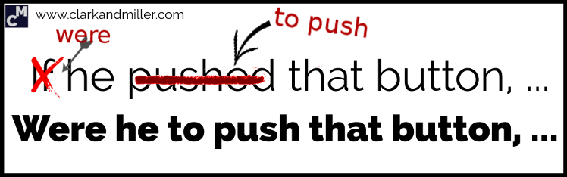

**Were** he **to push** the button, we’d all have problems.

***Example 2:***

If I was / were ridiculously rich, I think I’d still work.

**Were** I ridiculously rich, I think I’d still work.

***Example 3 - NEGATIVE:***

If it weren't for Miguel, we wouldn't know what to do now.

**Were** it **not** for Miguel, we wouldn't know what to do now.

**3rd Conditional**

***Example 1:***

If we had arrived sooner, we wouldn’t have missed the beginning.

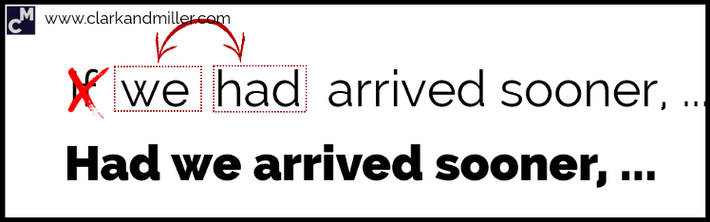

**Had** we **arrived** sooner, we wouldn’t have missed the beginning.

In negative clauses with inversion, we don't use contracted forms:

***Example 2:***

If the people hadn’t been informed, the situation would have been much worse.

**Had** the people **not been** informed, the situation would have been much worse.

1. **When We Use a Negative Adverb or Adverb Phrase at the Beginning of the Sentence**

Usually, we put the expression at the beginning of the sentence to emphasize what we’re saying. It makes our sentence sound surprising or striking or unusual. It also sounds quite formal.

The inversion of the subject and the verb can take place after a clause that begins with:

hardly…when/before

rarely

never

seldom

only then

not only…. but

no sooner … than

scarcely…when/before

only later

nowhere

in no way

little

only in this way

on no condition

on no account

in/under no circumstances

**Examples**:

* ***Hardly****had I closed my door****when****I realized I had lost the keys.*
* ***Rarely****has he got mark 10 in Math.*
* ***Never****have I met such well-behaved children before. They are as good as gold.*
* ***Seldom****do we receive any apology when mistakes are made.*
* ***Only then****did I understand the problem.*
* ***Not only****was it raining all day at the wedding****but also****the band was late.*
* ***No sooner****had I arrived home****than****the phone rang.*
* ***Scarcely****had I got off the bus****when****it crashed into the back of a car.*
* ***Only later****did she realize her mistake.*
* ***Nowhere****is the effect of government policy more apparent than in agriculture.*
* ***In no way****can theory be separated from practice.*
* ***Little****does she understand me.*
* ***Only in this way****can any future generations gain a balanced view of society in our time.*
* ***On no condition****should untrained personnel use the equipment.*
* ***On no account****should the house be left unlocked.*
* ***Under no circumstances****is the money to be paid.*

1. **Inversion in the second part of the sentence**

In the following expressions, the inversion comes in the second part of the sentence:

**Not until** Not until I saw John with my own eyes did I really believe he was safe.

**Not since** Not since Lucy left college had she had such a wonderful time.

**Only after** Only after I'd seen her flat did I understand why she wanted to live there.

**Only when** Only when we'd all arrived home did I feel calm.

**Only by** Only by working extremely hard could we afford to eat.

1. **We Can Use Inversion after**

**“So/such …that”**

For emphatic reasons.

**Examples:**

**So** loud was the noise **that** I couldn’t work.

**Such** was a day **that** we will all remember forever.

1. **We can use inversion if we put an adverbial expression of place at the beginning on the sentence.**

This is also quite formal or literary.

**Examples:**

On the table was all the money we had lost.

(Normal sentence: *All the money we had lost was on the table*.)

Round the corner came the knights.

(Normal sentence: *The knights came round the corner*.)