Writing : A For & Against Essay

Worksheet 1 - 1η Διδακτική ΄Ωρα

In the presentation that follows you are going to watch all the things you need to know about writing a short argumentative essay. Now click on the picture to start watching!

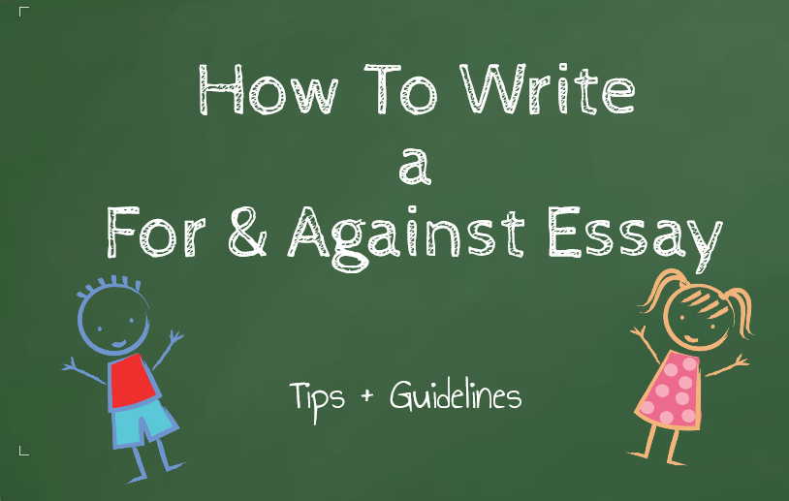

Now that you know…

Activity 1: Time to make everything right!

Look carefully at this jumbled mind map and use what you have already learned about how an essay of this type is organized.
- First, drag each popplet box and drop it in the correct place
- Second, draw the lines that match the correct paragraphs to the correct content.
- Ask for your teacher’s feedback.

Homework: For next time’s lesson, study what the structure of such an essay should be as well as the relevant linking words and expressions. Use the photocopy with the most important points of the presentation.

Worksheet 2 - 2η Διδακτική ΄Ωρα

Activity 3: Time to practice paragraph writing!
Read the two paragraphs and complete tasks a and b.
The Pros and Cons of Living in a Block of Flats
Paragraph 1
There are actually many good reasons why living in a block of flats can be a positive experience. Firstly, flats are usually conveniently located close to town centers. This means that amenities and facilities such as shops and banks are close by. In addition, living in a block of flats can be quite cheap. Rents and household bills are usually reasonable and residents can save on expensive car parking or public transport cost as their home may be near enough to work or college to walk there. Lastly, residents can often enjoy a great community spirit in blocks of flats. This is because they live so close together.

Paragraph 2
On the other hand, there can be plenty of disadvantages to living in flats. To start with, the blocks are often in unattractive, inner city areas. Also life can be uncomfortable there. City flats are often cramped and noisy, for example, with little privacy and storage space. Also, they rarely have outside space. For example, there is often no private garden.

a) Find the two topic sentences in the model paragraphs and highlight them with different colors:
Topic Sentence / Supporting Sentences: Reasons / Justifications / Examples
- Which sentences support them?
- Which include: reasons / justifications / examples?

b) Replace the topic sentences with other appropriate ones. Write them down on the space provided on the photocopied worksheet.
……………………………………………………………………………………………………………………………………………………………………………………………………………………………………………………………………………………………………………………………………………………………………………………………………………………………………………………………………………………………………………………………………………………………………………………………………………………………………………………………………………………………………………………………………………………………………………………………

Activity 4: Time to put the paragraph in order!
Put the sentences (A - E) in the paragraph in order. Which is the topic sentence?

Match the items on the right to the items on the left. Draw lines. Circle the topic sentence.

A Not only this, but it's great to have good, supportive friends living close by.

B To start with, they can keep an eye on your house when you're not at home.

C These days, our busy lives can be lonely and difficult and it helps greatly if a
neighbor can pop round for a cup of coffee or walk your dog when you are ill.

D They can water your plants and feed your pets when you're on holiday, for
example, and would notice any vandals or burglars

E There are many advantages to getting on well with your neighbors.

Activity 5: Time for Group Work!
In groups of four try to find what the Pros and Cons of Social Networking nowadays are.

- Find at least 3 advantages and 3 disadvantages
- Write your ideas on this mind map . Write the Pros in the blue Popplet boxes and the Cons in the red Popplet boxes.

