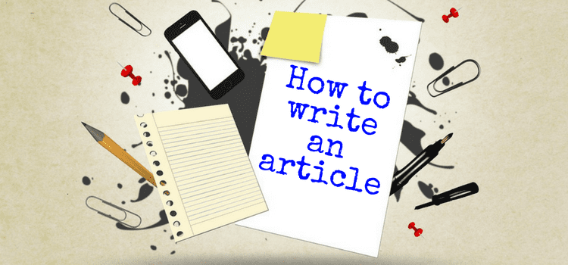
Homework 2: “My Vincent Van Gogh”

It is extremely important to read the instructions carefully, as you are supposed to obtain all the information you need to write the article. In this case we can see the following:
- Where our article will be published: a school magazine
- Topic: Vincent Van Gogh
- Main ideas: presenting his life and work from your own point of view.
And that’s exactly how we will organise our article, knowing exactly what to talk about in each paragraph.
- It should be visually appealing: The structure should be clear, leaving space between paragraphs and defining a clear introduction and conclusion.
- Each paragraph must have a clear objective.
  - The introduction presents the topic in a general way, but making clear what the article is about: Vincent Van Gogh
  - The second paragraph talks about Vincent’s life your point of view
  - The third paragraph talks about his work your point of view
  - The conclusion is a summary of sorts and we could ask the reader for some feedback on their own opinion about Vincent.

Structure:The structure of an article for a newspaper, magazine or website, is usually in three parts:
- introduction – engaging the reader, or outlining the main point of the article to follow
- middle – making clear and interesting points about the topic
- end – a concluding paragraph that draws the points together
If the aim of an article is to persuade the reader, then the opening and closing paragraph will outline the writer’s viewpoint and make it most memorable. Subheadings are sometimes used to signpost the content of each paragraph.

- The language is informal

Useful Expressions to Write an Article

If you want to know how to write an article, it is very important to have a repository of useful expressions ready to use. So here are some which can come in handy:

Rhetorical questions
  - Have you ever…?
  - Do you ever wonder…?
  - What do you think about…?
  - Are you a… like me?
  - Are you one of those people who…?
  - What would you say if I told you that…?

Concluding the article:
  - In conclusion,
On the whole,
To sum up,
To conclude,
All in all,
… you will not regret it!

Introducing new ideas:
  - Firstly,
  - First,
  - In the 1rst place,
  - To begin with,
  - The coolest thing about
  - What attracts me most
  - One thing to consider is
  - Another consideration is
  - Secondly,
  - As for
  - As to
  - Also,
  - As regards
  - In addition,
  - In addition to that,
  - Moreover,

Informal language
- Phrasal verbs: put you up, check out.
- Contractions: Isn’t that fantastic?
- Colloquial phrases: one of the cool things, I totally recommend it, etc.
- We address the reader directly: What about you?
- Exclamation marks: …find the answer!

How to write an article - best practice
https://www.youtube.com/watch?v=QTId9RFPKuQ
How to write an Article (Cambridge First, Advanced; Blogs)
https://www.youtube.com/watch?v=MbMMZ4rPrfI
How to Write Articles the Quick and Easy Way?
https://www.youtube.com/watch?v=u1g7oNGw-Xs

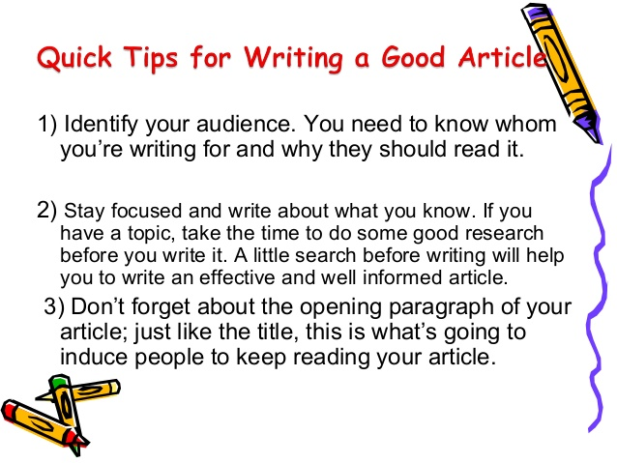
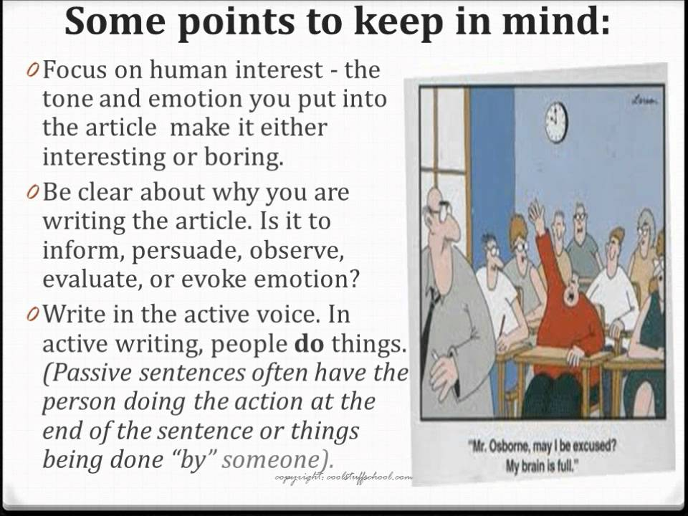

Same or different?
Circle the correct word in italics in each sentence.
a) Such a dark colour doesn’t really inspire/reflect your true personality
b) What shade of blue do you ensure/suggest I use?
c) That black tie doesn’t match / suit your shirt.
d) She uses pink to indicate/express how she feels.
e) Please tell/convey my best wishes to your parents.
f) The colours in the Greek flag represent/ offer the blue of the sea and the white of the clouds.
g) We didn’t understand/recognize you with your fake eyelashes and wig.

Replace the words in bold with one of the adjectives or adverbs from the lists.
A
That day, Amy and Mark couldn’t believe their bad luck! They had gone skiing 1) many times before, but they had never experienced such 2) cold temperatures and 3) strong winds. They realized they would have to find shelter 4) fast before they got into 5) serious trouble.
Countless fierce terrible
quickly freezing
C
The 1) old lady lived in a(n) 2) big house on a(n) 3) quiet street near the edge of town. She had lived there all her life and her house was filled with 4) nice 5) old furniture and collectibles. She spent most of her time in a(n) 6) small parlour at the back of the house, in front of a(n) 7) nice fire, reading books.
Large antique elderly beautiful
peaceful blazing tiny
B
Tom and Jane had just shared a 1) nice evening out with friends. On their way home, driving along a mountain road, they suddenly saw a9n0 2)big rock blocking their way. Tom slammed on the brakes immediately and managed to stop the car. They were 3) very lucky because they 4) just missed having a(n) 5) bad accident.
Huge awful narrowly
extremely pleasant

Use the words given in capitals to form a word that fits the gap. There is one example at the beginning.
What does it take to become an artist?
Have you ever wanted to become a 0) painter? It doesn’t matter whether you’re just a 1) who has just taken up painting or a 2) artist, there is always room for improvement in art. However, people starting a new 3)
are often too eager to produce results 4) However, for newcomers to painting a lot of 5)
is required. Plenty of practice is also needed to develop 6) talents. Visiting galleries and museums will help you to get an eye for the colours and styles that you like. You should also gain some 7) of the various paints and brushes. Then, it’s time to start learning the basics of colour. An 8) of the properties of colour will prove invaluable to any 9) artist. 10) , and perhaps most importantly, keep it fun!
PAINT BEGIN PROFESSION
PURSUE INSTANT PATIENT
ARTIST

KNOW
UNDERSTAND
AMBITION FINAL

