4. Vincent Van Gogh - Vocabulary Worksheet Class A
Lesson 1

A. Can you match the artists to their paintings?
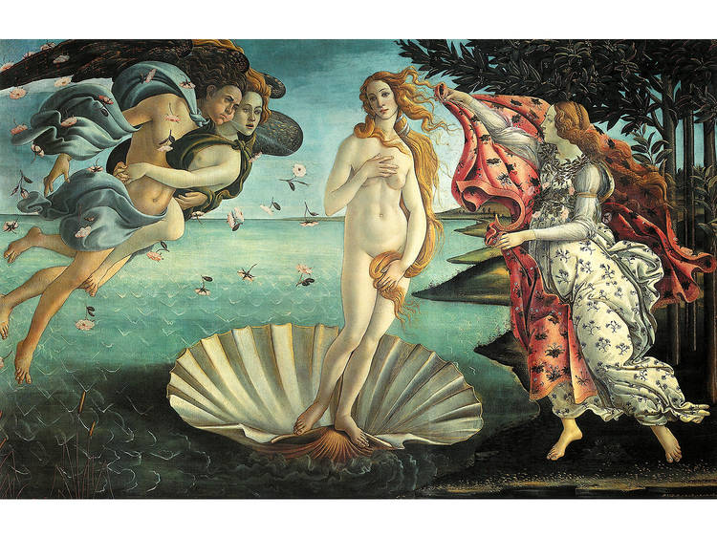
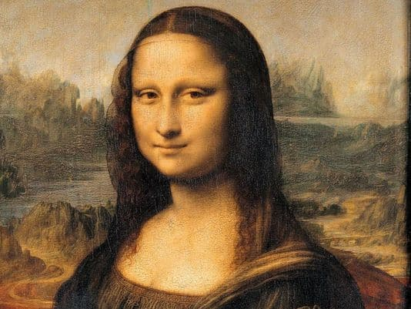

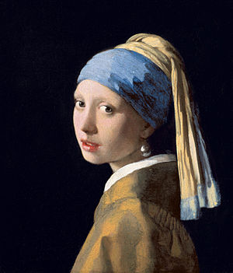

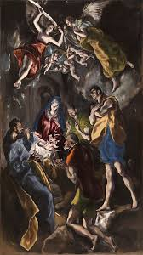
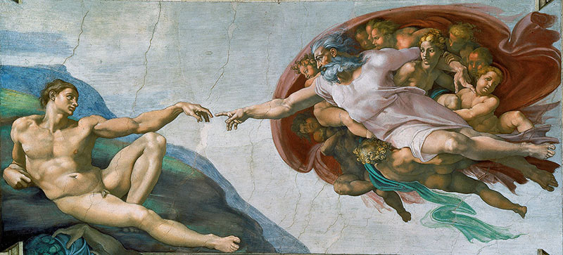

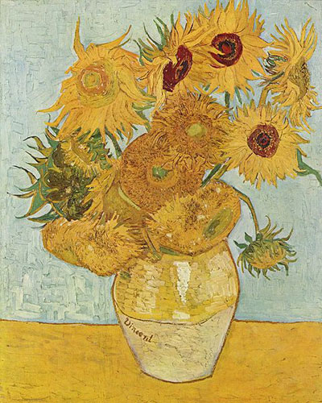

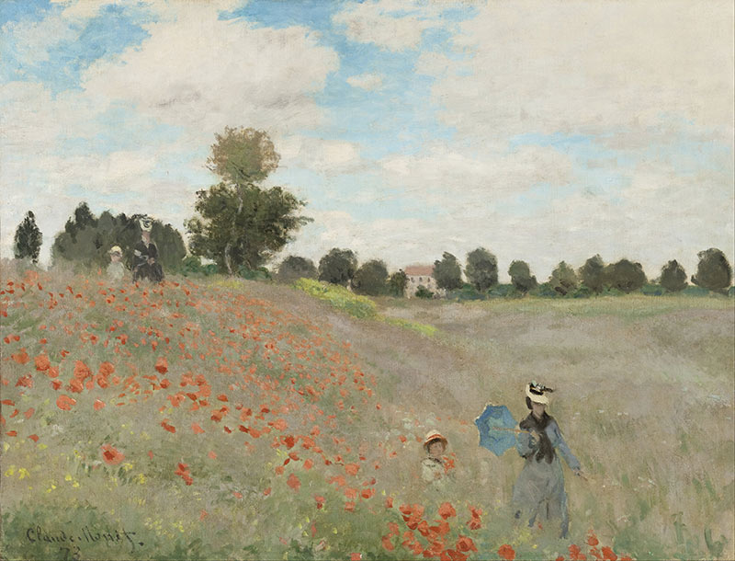

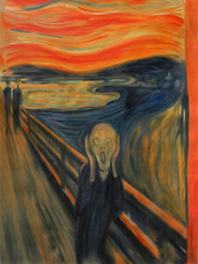

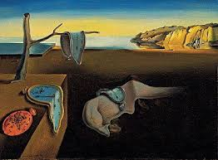
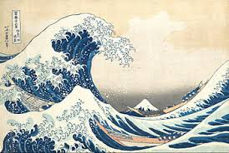

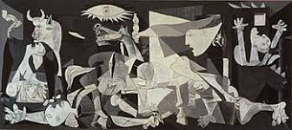

* Write the correct number in the boxes on the right of the table.

VINCENT VAN GOGH - Sunflowers
CLAUDE MONET - Poppy Field
PABLO PICASSO - Guernica
SALVADOR DALI - The Persistence of Memory
EL GRECO - The Adoration of the Shepherds
JOHANNES VERMEER - Girl with a Pearl Earring
EDVARD MUNCH - The Scream
LEONARDO DA VINCI - Mona Lisa
HOKUSAI KATSUSHIKA - The Great Wave of Kanagawa
MICHELANGELO - Creation of Adam
BOTTICELLI - The Birth of Venus

B. Can you find the names of the artist's materials which are shown below?

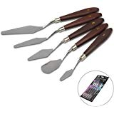
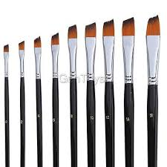
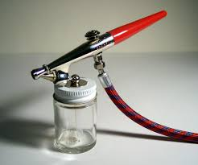
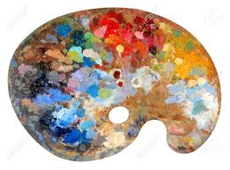

b_____________ p_______________ a_____- b_________ s____________
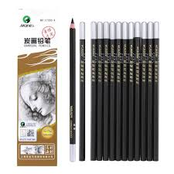
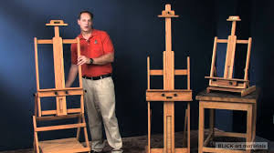
or p__________ k________

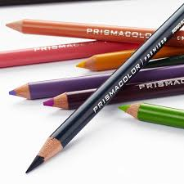

c___________ p__________ e__________________ c______________ p___________

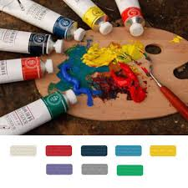
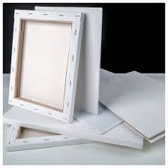

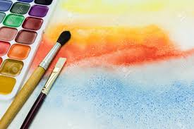

c_______________ o_____ - p____________ w___________- c___________
or A________________

Word List - “Starry – starry Night”

