**Εμβαθύνουμε στα τραπέζια**

**Δραστηριότητα 1:**

Μια εταιρεία τοπίου σχεδιάζει ένα αθλητικό πάρκο σε σχήμα τραπεζίου για έναν δήμο. Οι παράλληλες πλευρές του τραπεζίου είναι ο βόρειος και ο νότιος φράχτης του πάρκου, με μήκη 50 μέτρα και 30 μέτρα αντίστοιχα. Ο σχεδιαστής θέλει να τοποθετήσει ένα παγκάκι στη μέση του πάρκου, πάνω στη διάμεσο που ενώνει τα μέσα των μη παράλληλων πλευρών. Ταυτόχρονα, ο σχεδιαστής σχεδιάζει ένα μικρό μονοπάτι που θα ενώνει τα μέσα των διαγωνίων του τραπεζίου και θα είναι παράλληλο προς τις βάσεις.

Ερωτήματα:

* Ποιο θα είναι το μήκος της διαμέσου του τραπεζίου, όπου θα τοποθετηθεί το παγκάκι;
* Αν οι διαγώνιοι του τραπεζίου είναι 40 μέτρα και 60 μέτρα, ποιο θα είναι το μήκος του τμήματος που ενώνει τα μέσα των διαγωνίων;

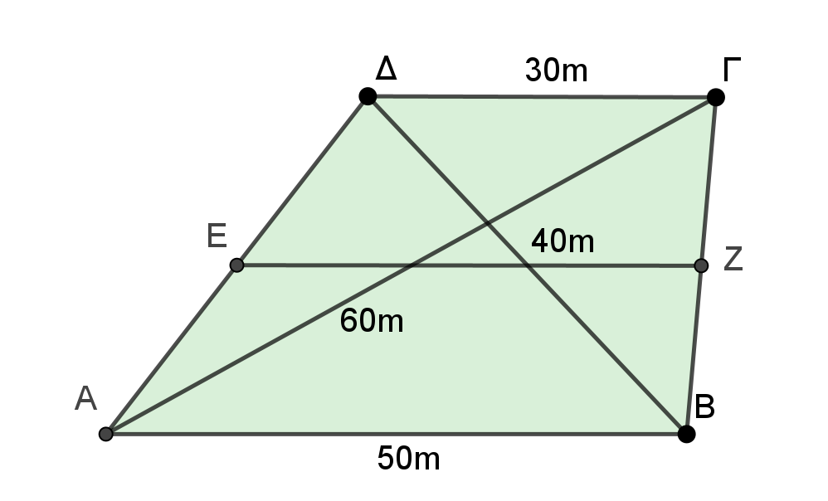

________________________________________________________________________________________________________________________________________________________________________________________________________________________________________________________________________________________________________________________________________________________________________________________________________________________________________________________________________________________________________________________________________________________________________________________________________________________________________________________________________________________________________________________________________________________________________________________________________________________________________________________________________________________________________________________________________________________________________________________________________________________________________________________________________________________________________________________________________________________________________________________________

**Δραστηριότητα 2:**

Δίνεται τραπέζιο ΑΒΓΔ με Â = Δ̂ = 90° και B̂ = 120°. Αν ΑΒ = 20 και ΒΓ = 10 να υπολογίσετε τη διάμεσο ΕΖ.

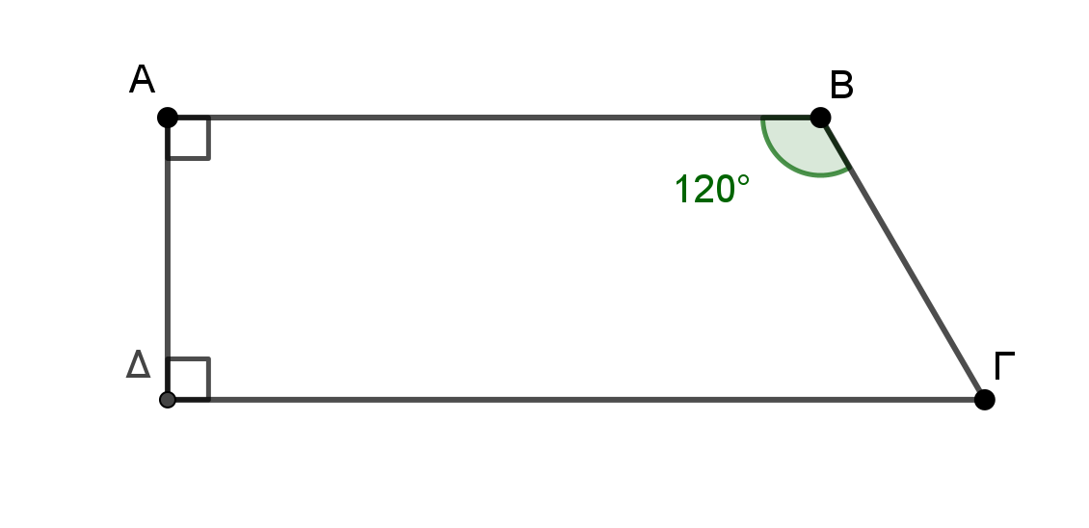________________________________________________________________

________________________________________________________________________________________________________________________________________________________________________________________________________________________________________________________________________________________________________________________________________________________________________________________________________________________________________________________________________________________________________________________________________________________________________________________________________________________________________________________________________________________________________________________________________________________________________________________________________________________________________________________________________________________________________________________________________________________________________________________________________________________________________________________________________________________________________________________________________________________________________________________________________________________________________________________________________________________________________________________________________________________________________________________________________________________________________________________________________________________________________________________________________________________________________________________________________________________________________________________________________________________________________________________________

**Δραστηριότητα 3:**

Σε ένα τραπέζιο ΑΒΓΔ, η μία από τις μη παράλληλες πλευρές του ΑΔ είναι ίση με το άθροισμα των βάσεων. Αν Μ είναι το μέσο της ΒΓ, να αποδείξετε ότι ΑM̂Δ = 90°.

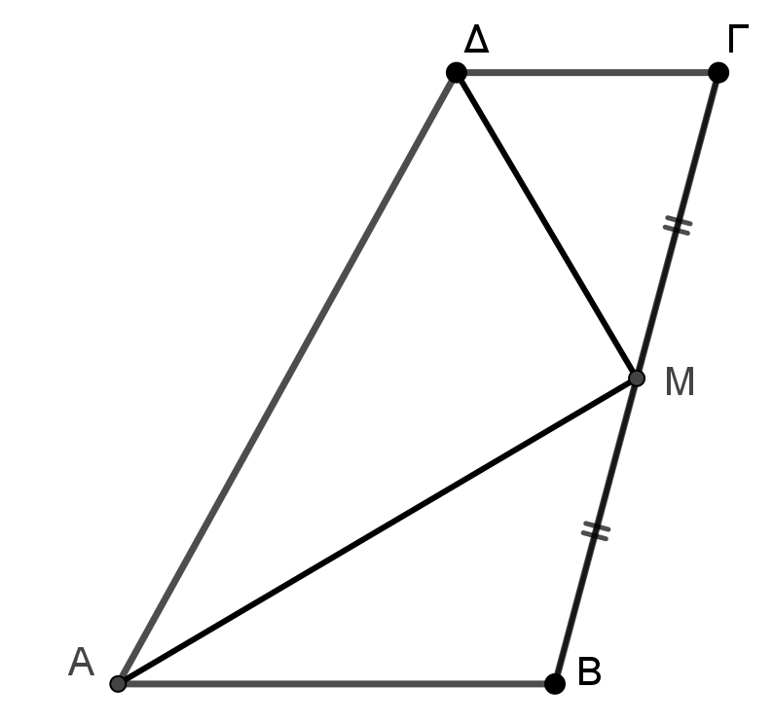

________________________________________________________________________________________________________________________________________________________________________________________________________________________________________________________________________________________________________________________________________________________________________________________________________________________________________________________________________________________________________________________________________________________________________________________________________________________________________________________________________________________________________________________________________________________________________________________________________________________________________________________________________________________________________________________________________________________________________________________________________________________________________________________________________________________________________________________________________________________________________________________________________________________________________________________________________________________________________________________________________________________________________________________________________________________________________________________________

**Δραστηριότητα 4 :**

Δίνεται τραπέζιο ΑΒΓΔ (ΑΒ//ΓΔ) με ΓΔ = 3ΑΒ και Κ, Λ τα μέσα των διαγωνίων

του ΔΒ και ΑΓ αντίστοιχα. Να αποδείξετε ότι το ΑΚΛΒ είναι παραλληλόγραμμο. Πότε αυτό είναι ορθογώνιο;

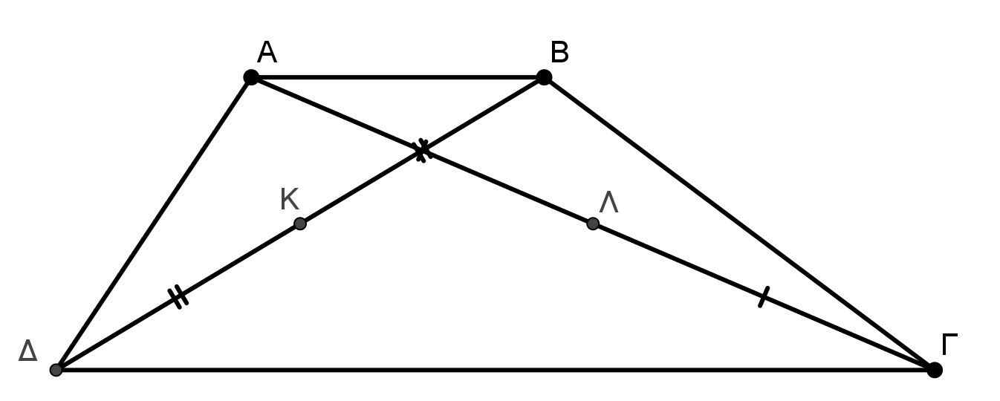

________________________________________________________________________________________________________________________________________________________________________________________________________________________________________________________________________________________________________________________________________________________________________________________________________________________________________________________________________________________________________________________________________________________________________________________________________________________________________________________________________________________________________________________________________________________________________________________________________________________________________________________________________________________________________________________________________________________________________________________________________________________________________________________________________________________________________________________________________________________________________________________________________________________________________________________________________________________________________________________________________________________________________________________________________________________________________________________________________________________________________________________________________________________________________________________________________________________________________________________________________________________________________________________________________________________________________________________________

**Δραστηριότητα 5:**

Δίνεται τραπέζιο ΑΒΓΔ με Â = Δ̂ = 90° και ΒΓ = 2ΓΔ. Αν Μ είναι το μέσο της ΒΓ, να αποδείξετε ότι ΑM̂Γ = 3ΜÂΒ. (Υπόδειξη: φέρτε ΜΕ κάθετη στην ΑΔ).



