Student Worksheet
Activity 1

These are your answers to the question about famous London landmarks.

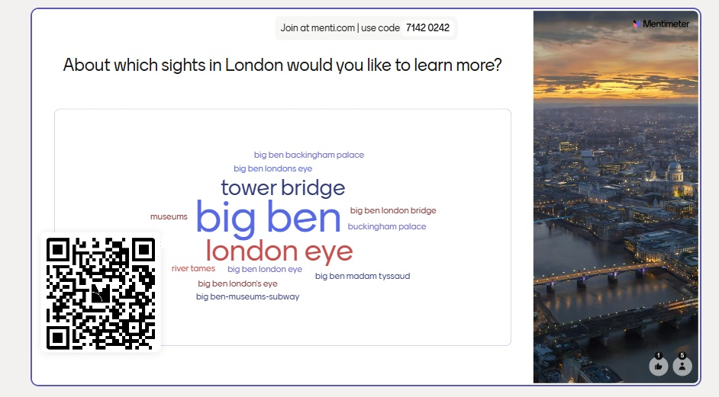

The most frequent words are represented in a larger size.
Which as the 4 words used more frequently?
- ………………………………….
- ………………………………….
- ………………………………….
- ………………………………….

Activity 2
Work in groups of 4:

- match each photo with the correct landmark

London Eye Tower Bridge Buckingham Palace Big Ben
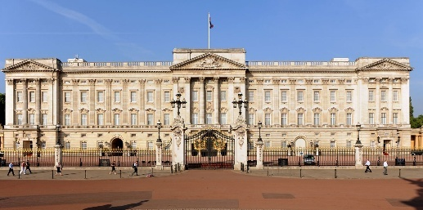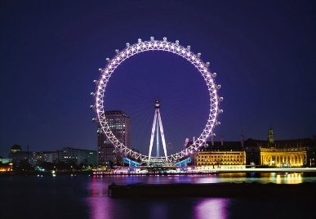
………………………………….. …………………………………
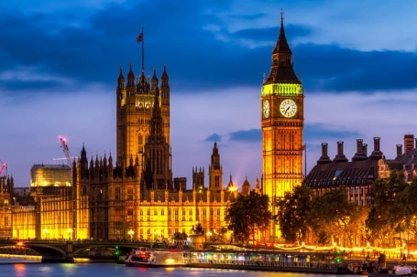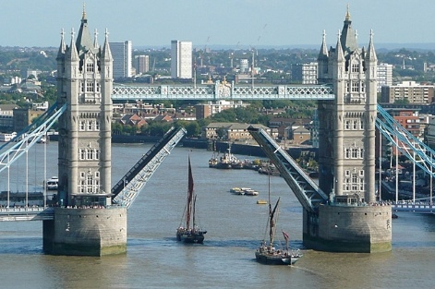
……………………………….. …………………………………

Check your answers as a whole class here.

- look at the photos of the landmarks discuss with your partners and write down in the table below
- which is the most distinctive feature of each
- one thing you would like to learn about each landmark.

You should also choose the member of the group who will add your ideas to the class document.

Place | Distinctive feature | Want to learn
London Eye

Tower Bridge

Buckingham Palace

Big Ben

Activity 3 - Student A
- Look at the text your teacher is showing on the interactive board.

- What kind of text is it? How do you know? To whom is it addressed?

- Work in groups of four. Each member of your group will read about only one of the landmarks:
- read your paragraph carefully
- answer the questions the other members of your group will ask you about your landmark
- ask the members of your group the correct questions in order to fill in the missing information in the table below. At the end of the activity, the table should be completed with all the necessary information.

London Eye The London Eye is a giant observation wheel on the South Bank of the River Thames, which was completed and opened to the public in 2000. It was constructed as a landmark to celebrate the new millennium. Even though it was only meant to be up for five years, it was so popular that it was made a permanent addition to London's iconic skyline. As it stands about 135m tall in a fairly flat city, it is visible from many surprising parts of it. A ride or a “flight”, as it is called here, in one of the wheel’s 32 glass pods holding up to 28 people, takes roughly 30 minutes and attracts 3.5 million visitors annually. From inside a capsule you have a panoramic view of London’s major landmarks such as St. Paul’s Cathedral, the Houses of Parliament and the Shard.

 | Built in | Reason | Height | Highlight
TowerBridge
Buckingham Palace
Big Ben

Activity 4
Read your text again. Can you guess the meaning of the underlined words and phrases? You can either explain their meaning in English, provide a synonym or use it in a sentence.

When everyone has finished you will check your answers by doing this online exercise.

Activity 3 – Student B
Work in groups. Look at the text your teacher is showing on the interactive board.

- What kind of text is it? How do you know? To whom is it addressed?

Each member of your group will read about only one of the landmarks:
- read your paragraph carefully
- answer the questions the other members of your group will ask you about your landmark
- ask the members of your group the correct questions in order to fill in the missing information in the table below. In the end, the table should be completed with all the necessary information.

Tower Bridge With its two massive Gothic stone towers and bright blue suspension parts, Tower Bridge is one of the most photographed places in London. Built in 1894 was a major engineering project of the Victorian period as well as a much-needed crossing point in the east. It was equipped with a then revolutionary mechanism that could clear the way for oncoming ships in three minutes, the bridge still lifts around 1000 times a year and as often as 10 times a day in summer. It’s fascinating to get inside the bridge, take the lift to the top of the structure, 42 m above the river and walk across the high-level glass walkway which offers a breathtaking view of the river below. A truly unforgettable experience—especially if you’re brave enough to look down!

Gothic: a style of architecture of old buildings that look impressive and tall with high thin-pointed towers and colourful windows.

 | Built in | Reason | Height | Highlight
London Eye

Buckingham Palace
Big Ben

Activity 4
Read your text again. Can you guess the meaning of the underlined words and phrases? You can either explain their meaning in English, or provide a synonym or use it in a sentence.

When everyone has finished you will check your answers by doing this online exercise.
Activity 3 – Student C
Work in groups. Look at the text your teacher is showing on the interactive board.

- What kind of text is it? How do you know? To whom is it addressed?

Each member of your group will read about only one of the landmarks:
- read your paragraph carefully
- answer the questions the other members of your group will ask you about your landmark
- ask the members of your group the correct questions in order to fill in the missing information in the table below. In the end, the table should be completed with all the necessary information.

Buckingham Palace Buckingham Palace is the official London residence of the British monarch and one of the city’s most prestigious and historic buildings. It has been the royal family’s London home since 1837, although the original house was built in 1703 for the Duke of the same name. The palace is extremely impressive, with more than 775 rooms, including offices, state rooms, a private cinema and even a post office. The front is dominated by a long driveway and a famous balcony where the Royal Family appears during public events. The palace’s most famous attraction is ‘The Changing of the Guard’: a formal ceremony, accompanied by music, in which the soldiers who protect Buckingham Palace are replaced by a new group of guards.

 | Built in | Reason | Height | Highlight
London Eye

Tower Bridge

Big Ben

Activity 4
Read your text again. Can you guess the meaning of the underlined words and phrases? You can either explain their meaning in English, or provide a synonym or use it in a sentence.

When everyone has finished you will check your answers by doing this online exercise.

Activity 3 – Student D
Work in groups. Look at the text your teacher is showing on the interactive board.

- What kind of text is it? How do you know? To whom is it addressed?

Each member of your group will read about only one of the landmarks:
- read your paragraph carefully
- answer the questions the other members of your group will ask you about your landmark
- ask the members of your group the correct questions in order to fill in the missing information in the table below. In the end, the table should be completed with all the necessary information.

Big Ben is one of London’s most recognisable symbols. Many people don’t realise that “Big Ben” is actually the name of the massive bell inside the tower, while the tower itself was officially named Elizabeth Tower in 2012 in order to mark Queen Elizabeth’s Diamond Jubilee. The Gothic Clock Tower is part of the Houses of Parliament, where England’s political parties meet to discuss and solve the country’s problems. Completed in 1859, the tower has survived fires, storms and even bombings during World War II. Today, it plays an important role: it keeps the official time of the UK. From the outside, the tower looks striking with its golden details and four enormous clock faces that light up after dark. The clock mechanism is so precise that even minor changes in weather can influence how it works. You can actually see the inner workings of the clock mechanism if you go on the guided tour of the Elizabeth Tower which takes you up a narrow 334-step spiral stairwell to the belfry at a height of 96 metres where the Great Bell hangs.

 | Built in | Reason | Height | Highlight
London Eye

Buckingham Palace
Tower Bridge

Activity 3
Read your text again. Can you guess the meaning of the underlined words and phrases? You can either explain their meaning in English, or provide a synonym or use it in a sentence.

When everyone has finished you will check your answers by doing this online exercise.

Activity 5
- How much have you learnt about London’s landmarks?
You will take part in a Kahoot quiz with your group to find out. You have to work as a team if you want to be on the podium.
Go to Kahoot.it and join in with the game pin for the game that you see on the interactive board.
- Go back to the question your group asked at the beginning of the lesson. Has it been answered? If no, search on the Internet and share it with the class in the next lesson.

Activity 5 - Homework
- Go back to activity 2, has your group’s question been answered? If not, search on the Internet to find the answer and share it with the whole class in the next lesson.
- Visit the eclass section of your lesson (Αγγλικά Β΄Γυμνασίου) and in the Section: Getting to know London, go to the class London padlet. Add a post in this padlet, saying which place you would like to visit in London and why. You can use information from the texts covered in the lesson of you can search the Internet for some more. Comment on at least one of your classmates’ posts.

