Can you guess how many emotions a human can experience?
It’s around 34,000.
With so many emotions, how can one navigate the turbulent waters of feelings, without getting lost?
The answer: with an emotion wheel.
Through years of studying emotions, American psychologist Dr. Robert Plutchik proposed that there are eight primary emotions that serve as the foundation for all others: joy, sadness, acceptance, disgust, fear, anger, surprise, and anticipation. (Pollack, 2016)
So while it’s hard to understand all 34,000 distinct emotions, we can learn how to identify the primary emotions and act accordingly. It’s especially useful for moments of intense feeling and when the mind cannot remain objective as it operates from an impulsive “fight or flight” response. (Watkins, 2014)
The Wheel of Emotions
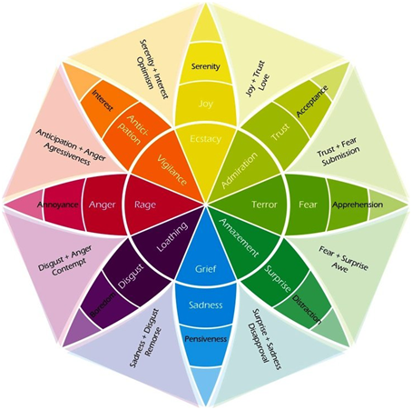
The eight primary emotions that he identified, which are the basis for all others, are grouped into polar opposites:
- joy and sadness
- acceptance and disgust
- fear and anger
- surprise and anticipation
The foundation of his emotions theory stems from the following ten postulates:
(Changing Minds, 2016)
- Animals and Humans
The midbrain (or the limbic system) of a human is similar to that of other mammals. Animals and humans experience the same basic emotions.
- Evolutionary History
Emotions came into being as part of the evolutionary process, long before there were apes or humans.
- Survival Issues
The most influential role of emotions is to help us survive.
- Prototype Patterns
These are the common identifiable patterns and elements that make up each emotion.
- Basic Emotions
The most basic emotions are the primary ones: trust, fear, surprise, sadness, disgust, anger, anticipation and joy.
- Combinations
The adding up of these various primary emotions will produce new ones such as: love = (joy+ trust), guilt = (joy + fear), and delight = (joy + surprise).
- Hypothetical Constructs
Emotions are constructs, or ideas, that help describe a certain experience.
- Opposites
Like many things in nature, there is a duality with emotions, hence each one has its polar opposite:
– saddens is the opposite of joy
– trust is the opposite of disgust
– fear is the opposite of anger
– surprise is the opposite of anticipation
- Similarity
The degree of similarity determines which emotions are more related, and which ones are the complete opposite.
- Intensity
This degree of change in intensity, from very strong to not so much, produces the diverse amount of emotions we can feel. Such as:
– trust goes from acceptance to admiration
– fear goes from timidity to terror
– surprise goes from uncertainty to amazement
– sadness goes from gloominess to grief
– disgust goes from dislike to loathing
– anger goes from annoyance to fury
– anticipation goes from interest to vigilance
– joy goes from serenity to ecstasy
Source: https://positivepsychology.com/emotion-wheel/

Questions
1. How many emotions can a human experience?
2. In what way is the wheel of emotions useful?
3. How are the basic emotions presented?
4. What purpose do emotions fulfill?
5. How would you define emotions?
6. Can primary emotions be combined? To what end?
7. How is the vast amount of emotions generated?

