UNIT 5. ANIMAL RIGHTS

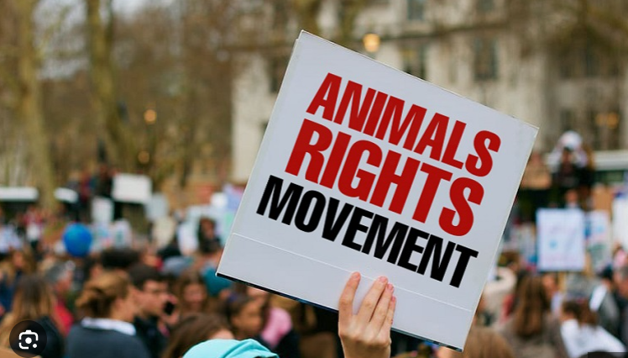

There is much disagreement as to whether animals have rights or not. What do you think?

Discuss the following questions, keeping notes:

1. Are animals man's property?

2. Is it alright if we kill animals for food?

3. Is it alright if we use animals for hard labour?

4. Is it alright if we use animals for entertainment?

5. Can you think of any other cases that cause disagreement concerning animal rights?

6. Which treatment is considered unethical?

7. Can using or killing animals be justified for special reasons?

