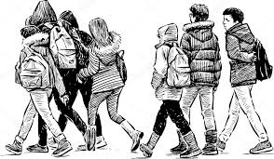
My name is ___________________________.
My country is _____________________.
I am ______________ years old. My birthday is on _________________.
I live in _____________.
My favourite food is ________________________.
My favourite number is ______________ .
My favoutrite season is _________________________.
My favourite place is______________________.
My favourite colour is _____________________________.
My favourite app is ___________________.
My favourite school subject is __________________________________.
I think my talent is to _____________________________________________________________.
In my free time I like to _____________________________________________________________.
I use the Internet to _____________________________________________________________.
When I finish school I want to ___________________________________________________________.

