Muzon’s Story: A Teenage Refugee Championing Girls’ Education (Part 1)

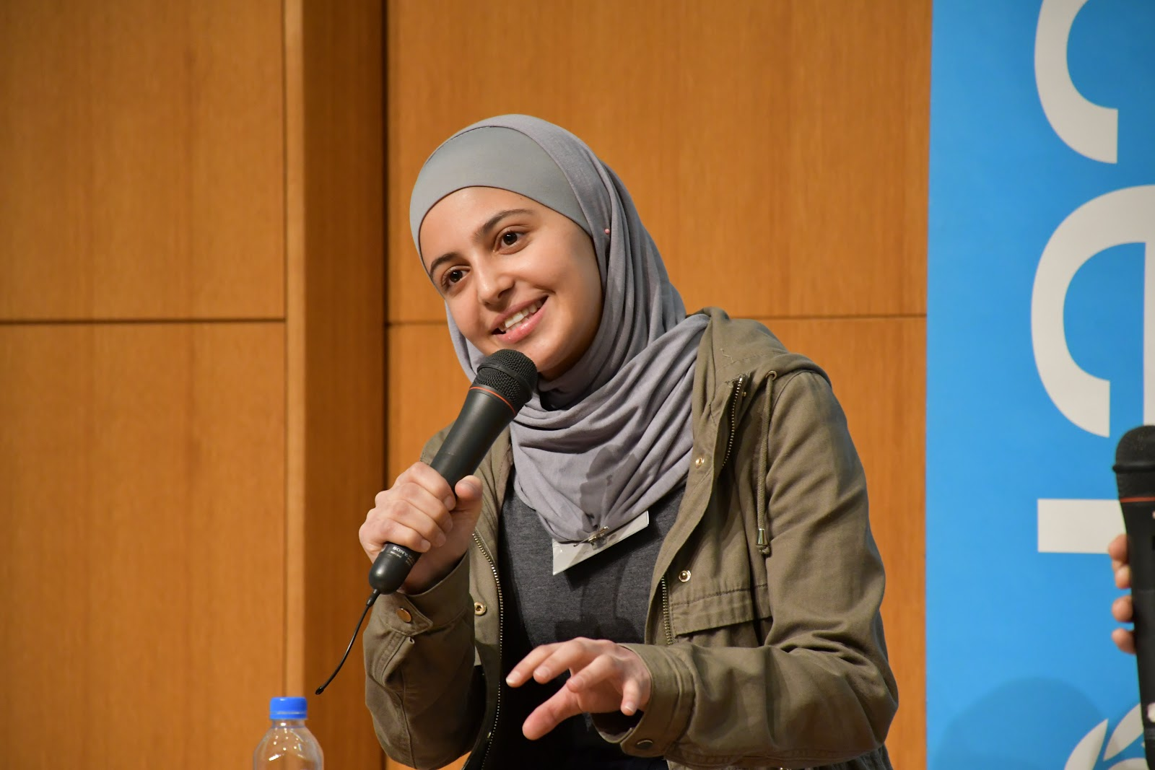
Part A – Reading Comprehension (Multiple Choice)
- Choose the best answer (A–D).

- Why did Muzon’s family initially hesitate to take her with them when fleeing Syria?
A. They feared she would not adapt to life in Jordan.
B. Her aunt suggested she should stay to finish her exams.
C. They were unsure whether schools existed in the refugee camps.
D. She was too young to travel such a long distance.

- What reason did Muzon’s father give for insisting she leave Syria with the family?
A. He thought education could always be continued later, but life could not.
B. He wanted her to study under the Jordanian curriculum.
C. He believed Jordan offered better medical facilities.
D. He feared she would be recruited into the conflict.

- Which of the following best describes Muzon’s attitude towards education?
A. She values it mainly because her family worked in schools.
B. She sees it as a pathway to wealth and social status.
C. She considers it fundamental to every aspect of life.
D. She regards it as important but secondary to personal freedom.

- Why has Muzon been compared to Malala?
A. Both were awarded the Nobel Peace Prize.
B. Both faced attacks while advocating for education.
C. Both became internationally recognised campaigners for girls’ education.
D. Both left their home countries to study abroad.

- What was Muzon most relieved to discover upon arriving in Za’atari refugee camp?
A. That her family would be given permanent housing.
B. That she could continue her education.
C. That her family had access to medical care.
D. That she could live with extended relatives.

Part B – Vocabulary in Context
- Task 1: Word Formation & Derivatives
Complete the sentences with the correct form of the word in brackets.

- Her ____________________ (convince) that education is vital inspired many young refugees.
- Despite countless acts of political _________________ (obstruct), she continued her schooling.
- Education is often the most powerful form of _________________ (empower).
- The family faced an extremely difficult _____________ (transit) from Syria to Jordan.
- He argued _____________ (force) in favour of education for all children.
6.Muzon’s passion for education became a ________________ (define) part of her identity in exile.
7. Her family’s decision to flee Syria was influenced by the ___________________ (danger) of living near a military base.
- Task 2: Collocations and Usage
Fill in the gaps with the most suitable collocation from the list below. There are two extra options you do not need to use.

make up for – deeply held – crossfire – advocate for – transition to – in exile – play a part –
draw inspiration from – overcome obstacles – endure hardship – seize opportunities – deeply rooted

- Muzon’s father argued that school exams could be postponed, but life could never be _________.
- Education has always ________________ in her life, influenced by her family background.
- During the war, the family was trapped in the _______________ between opposing forces.
- Muzon became a passionate _________________ girls’ education.
- Living ______________, she still remained determined to pursue her dreams.
- Her determination was ___________________ in her belief in the value of education.
- Refugee families must often ____________________ to survive and rebuild their lives.
- She managed to _______________ her friendship with Malala and continue her advocacy work.
- Young people are encouraged to ________________ strong role models.
- Refugees must learn to ________________ despite limited resources.

Essay (250–300 words):
“Education is the most powerful weapon which you can use to change the world” (Nelson Mandela).
Using Muzon’s story as inspiration, discuss how education can empower individuals and transform communities, particularly in crisis situations.

✅ Answer Key

Part A – Reading Comprehension (Multiple Choice)

B – Her aunt suggested she should stay to finish her exams.

A – He thought education could always be continued later, but life could not.

C – She considers it fundamental to every aspect of life.

C – Both became internationally recognised campaigners for girls’ education.

B – That she could continue her education.

Part B – Vocabulary in Context
Task 1: Word Meaning in Context

hailed as → a) praised as

defining feature → b) essential quality

high-profile → d) widely recognized

drawn comparisons with → e) likened to

dispelled → c) made irrelevant

Task 2: Word Formation & Derivatives

conviction

obstruction

empowerment

transition

forcefully

defining

dangerousness (or danger, acceptable depending on context)

Task 3: Collocations and Usage

made up for

played a part

crossfire

advocate for

in exile

deeply rooted

endure hardship

seize opportunities

draw inspiration from

overcome obstacles

👉 Now you have a complete worksheet + answer key ready for classroom use.
Would you like me to format everything into a clean, ready-to-print PDF with sections, space for answers, and the key at the end (for teacher use)?

