9^{ο} ΓΕΛ ΙΩΑΝΝΙΝΩΝ
ΣΧΟΛΙΚΗ ΧΡΟΝΙΑ 2020-2021

ΠΡΟΧΕΙΡΟ ΔΙΑΓΩΝΙΣΜΑ Α΄ ΤΕΤΡΑΜΗΝΟΥ ΣΤΟ ΜΑΘΗΜΑ ΤΩΝ ΑΓΓΛΙΚΩΝ
ΠΑΡΑΓΩΓΗ ΓΡΑΠΤΟΥ ΛΟΓΟΥ

Ονοματεπώνυμο:___________________________ Ημερομηνία:________________
Τάξη: Α___

D. Writing (30 points)
Read the story of Maximilian Kolbe and follow the guidelines to write a short summary (120 words). Your version should be an accurate summary of the original article containing all information which is of central importance.

Maximilian Kolbe was born in Poland in 1894. At the age of just 14, he had become ordained as a Franciscan friar, though he also carried on with his education, eventually earning a PhD in philosophy. During the 1920s and 1930s, he travelled widely, building a monastery in Japan and another in India, before poor health forced him to return to his native Poland in 1936.

When the Nazis invaded his country, Maximilian provided shelter to refugees from Greater Poland, including 2,000 Jews whom he hid from the Nazis in his monastery. That’s why, in February of 1941, his monastery was shut down and he was arrested by the Gestapo. Within a couple of days, he was being transferred to the infamous Auschwitz death camp, as prisoner number 16670.

In the camp, Maximilian saw it his duty to carry on in his priestly manner, even though this got him regular beatings. Then, in July 1941, came his ultimate test of faith. Ten prisoners had succeeded in escaping. In order to deter other outbreaks, the Nazi guards picked ten prisoners to be starved to death in an underground bunker. One of the men chosen cried out that he had a wife and children, so the priest offered to take his place among the condemned. So, along with nine others, he was thrown into the bunker and left to die a slow, agonizing death.

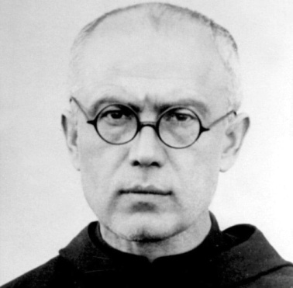
One of the men employed to clean the camp survived to tell the story. He revealed that Maximilian led the condemned men in prayer. In all, he lasted two weeks, and was the last of the prisoners to die. Indeed, the guards ultimately had to give him a lethal injection – which, according to witnesses, he accepted with good grace and serenity. He was canonized in 1982 and named a martyr of charity, as well as a patron saint for drug addicts, prisoners and families by the Roman Catholic Church. And the man whose place in the bunker he took? He lived to be 93 years old and dedicated much of his life to telling the world about his saviour’s act of sacrifice.

- WHO is the story about? Who is the main character?
- WHERE did the story take place?
- WHEN did the story take place?
- WHAT happened in the story?
- HOW does the story end?

__________________________________________________________________________________________________________________________________________________________________________________________________________________________________________________________________________________________________________________________________________________________________________________________________________________________________________________________________________________________________________________________________________________________________________________________________________________________________________________________________________________________________________________________________________________________________________________________________________________________________________________________________________________________________________________________________________________________________________________________________________________________________________________________________________________________________________________________________________________________________________________________________________________________________________________________________________________________________________________________________________________________________________________
_______________________________________________________________________________________________
_______________________________________________________________________________________________
_______________________________________________________________________________________________
_______________________________________________________________________________________________
_______________________________________________________________________________________________
_______________________________________________________________________________________________
_______________________________________________________________________________________________
_______________________________________________________________________________________________
_______________________________________________________________________________________________
_______________________________________________________________________________________________

