## ANCIENT EGYPT

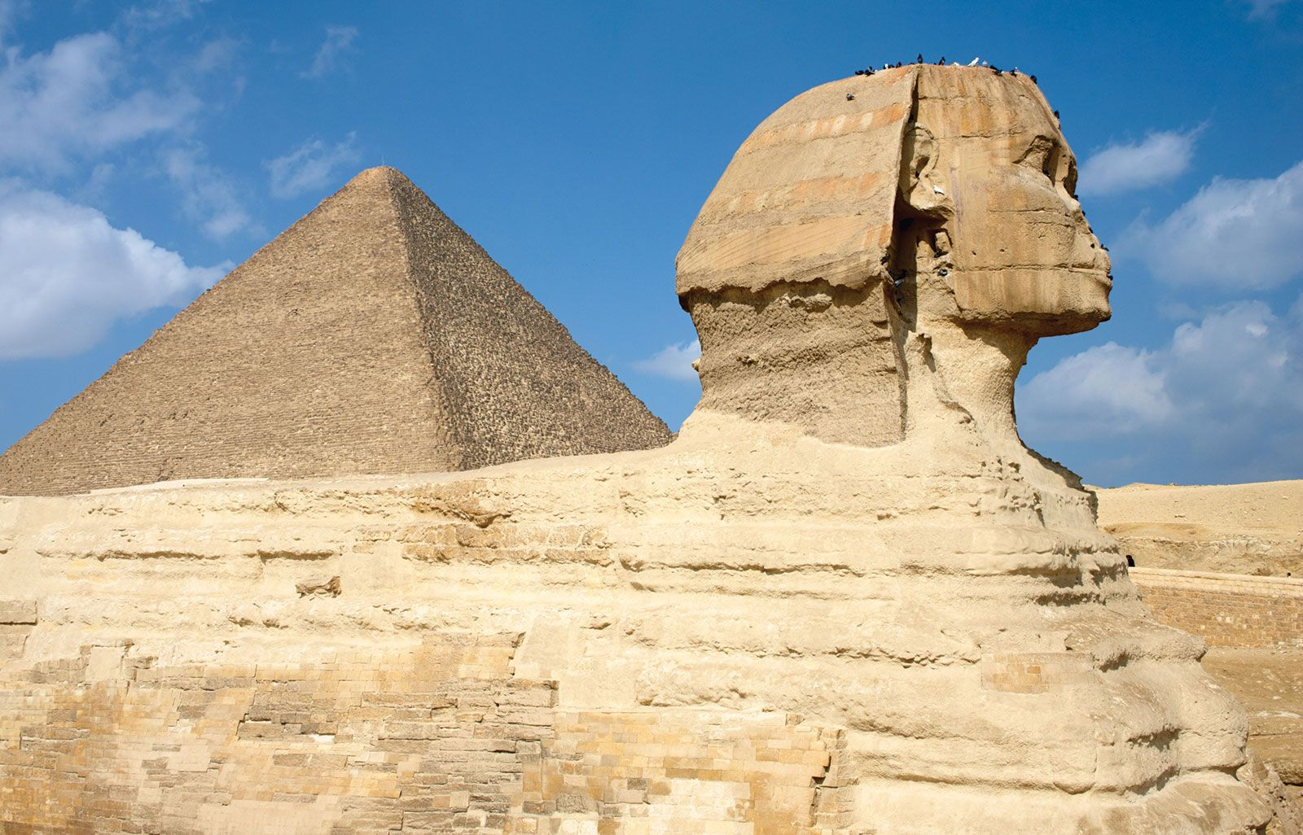

Ancient Egypt was one of the most remarkable civilizations in history, thriving along the Nile River in northeastern Africa for almost 3,000 years. The Nile was essential to Egyptian life, providing water for drinking, farming, and transportation. The annual flooding of the Nile deposited rich, fertile soil on its banks, allowing the Egyptians to grow abundant crops.

Egyptian society was structured into three major periods known as the Old Kingdom, the Middle Kingdom, and the New Kingdom. The Old Kingdom, also known as the "Age of the Pyramids," saw the construction of the Great Pyramid of Giza, one of the Seven Wonders of the Ancient World. During the Middle Kingdom, Egypt experienced political stability and economic prosperity, and the arts flourished. The New Kingdom was Egypt's most powerful era, marked by significant military conquests and the rule of famous pharaohs such as Tutankhamun and Ramses II.

Daily life in ancient Egypt varied greatly depending on social status. Nobles lived in large homes with many rooms, while peasants lived in smaller, simpler houses. Egyptians wore lightweight clothing suited to the hot climate, with men typically wearing kilts and women wearing long dresses.

Religion played a central role in Egyptian culture. The Egyptians believed in many gods, including Ra, the sun god, and Isis, the mother goddess. They also believed in an afterlife, which led to the practice of mummification to preserve bodies for the journey to the next world. The construction of elaborate tombs and pyramids was part of this belief system, ensuring that the dead were well-prepared for the afterlife.